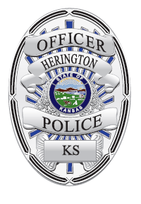 | Herington Police Department  Vigilance. Honor. Integrity.  700 South Broadway  Herington, Kansas 67449  (785) 258-2227  FAX: (785) 258-3453 | 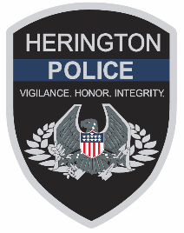

Herington Community
RE: Drive-by Shooting- July 6, 2022

On 7/6/2022 Officers were dispatched to a reported shooting at the intersection of S. B Street and Day Street in Herington, Kansas. The suspect has been identified as Travis Richardson of Abilene, he is a 26-year-old male that is approximately 5’9” tall, weighs approximately 140-150 pounds, and has short dark hair with short facial hair. Richardson confronted another subject that was walking at the above intersection following a confrontation at a nearby residence. Richardson produced a semi-automatic pistol and fired fourteen times at the victim before fleeing the scene, Richardson has not been located at this time.

No one was hurt as a result of the shooting, although some personal property was damaged by the rounds fired in the area. He is believed to be in the vehicle that he was driving at the time of the shooting which is described as a dark blue in color 2006 Cadillac STS bearing Kansas license plate 514LFG. The vehicle also has larger aftermarket chrome wheels. If you believe you see the vehicle or Richardson, please call 911 and do not approach him as he is considered armed and dangerous and could pose a danger to the public.

The investigation is still ongoing, and the Herington Police Department requests contact if you believe you have any information that may be helpful to the case or the suspect’s whereabouts.
Please contact Detective Cottone or Chief Langley with HPD if you have any information. Thank you.

Respectfully,
Chad Langley
Chief of Police
Herington Police Department
700 S. Broadway Street
Herington, KS 67449

