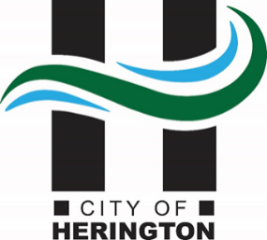
THE CITY OF HERINGTON
P.O. Box 31 • 17 North Broadway • Herington, KS 67449

Telephone: (785) 258-2271 FAX: (785) 258-3552

BOARD OF CONSTRUCTION, TRADES, & APPEALS AGENDA
HERINGTON CITY HALL
4:30 PM, Thursday, October 26, 2023

- PLEDGE OF ALLEGIANCE

- WELCOME AND CALL TO ORDER

- , called the Building Trades Board meeting to order on Friday, April 27, 2023, at City Hall.
Members present were: ______________________________________________
Members absent were:

- PUBLIC COMMENT PERIOD:

- APPROVAL OF MINUTES:

- APPROVAL OF AGENDA:

- OLD BUSINESS:

Discuss the proposed ordinance establishing license requirements and fees.

- NEW BUSINESS:

Discuss Adopting Bylaws

Discuss updating ICC codes

- NEXT MEETING DATE: ________________________, 4:30 PM at City Hall.

(Motion by)
(Second by)
Motion Passed -

- ADJOURNMENT

(Motion by)
(Second by)
Motion Passed -

