Comprehensive Plan:
City of Herington, Kansas

PREPARED FOR:
CITY OF HERINGTON, KANSAS 17 NORTH BROADWAY
HERINGTON, KANSAS 67449

PREPARED BY:

DEVELOPMENT INITIATIVES, INC.
P.O. BOX 7123
KANSAS CITY, MISSOURI 64113 PHONE816.916.3664
FAX 816.363.3664

PREPARED: NOVEMBER 18, 2001

Copyright Statement

This document was prepared for the intended use of the City of Herington, Kansas for it’s continued development and planning for the general community.

With the exception of the unlimited use by the City of Herington, Kansas, no part of this document may be reproduced, duplicated, or transmitted by mechanical, digital or other means without permission in writing from Development Initiatives, Incorporated.
Development Initiatives, Inc. retains all copyrights to the material located within this document and the material located herein is subjected to the U.S. Copyright Law found in the United States Code, Title 17, Chapter 1-13.

Table of Contents

Section 1: Executive Summary
Section 2: Planning Process
  - Introduction
  - Plan Outline
  - Public Participation
  - SWOT Analysis

Section 3: Project Area
  - Location and Boundaries
  - History of Herington

Section 4: Demographics
  - Introduction
  - Age and Population Distribution
  - Household Size and Type
  - Educational Attainment
  - Labor Force
  - Income and Poverty Status

Section 5: Land Use and Zoning
  - Introduction
  - Existing Land Use Conditions
    - Land Use Pattern
    - Residential Land Use
    - Commercial Land Use
    - Industrial Land Use
    - Parks and Open Space
    - Vacant/Undeveloped Land
  - Existing Zoning Conditions
    - Residential Zoning
    - Commercial/Business Zoning
    - Industrial Zoning
    - Agricultural Zoning
  - Hazard Mitigation Review
  - Planning Analysis, Goals, Objectives and Actions

Section 6: Housing
  - Introduction
  - Existing Housing Conditions and Trends
    - Housing Tenure
    - Vacancy Analysis
    - Mobility
    - Housing Affordability and Value
    - Housing Style and Size
    - Age, Size and Condition
  - Planning Analysis, Goals, Objectives and Actions

Table of Contents Continued

Section 7: Community Facilities and Services
  - Introduction
  - Capital Project Plan
  - City Hall
  - City Library
  - Schools
  - Healthcare Facilities
  - Parks and Recreational Facilities
  - Water
  - Electricity
  - Wastewater
  - Fire services
  - Police services
  - Street Maintenance
  - Solid Waste Disposal
  - Recycling Program
  - Survey Results
  - Planning Analysis, Goals, Objectives and Actions

Section 8: Economic Development
  - Introduction
  - Employment
  - Place of Work
  - Unemployment
  - Economic Base
  - Wages
  - Occupational Outlook
  - Local Economic Development
  - Rural Economic Growth
  - Planning Analysis, Goals, Objectives and Actions

Section 9: Implementation
  - Introduction
  - Implementation Framework
  - Evaluation of the Comprehensive Plan
  - Implementation Management
  - Action Plan

Appendices
1: Resident Survey & Summary 2: Steering Committee Members

Executive Summary

Project Area
Herington is situated on Lime Creek in the southeastern section of Dickinson County, approximately 25 miles south of Junction City and 15 miles from Lyndon. Although the majority of the City is located on level valley land, the western edge of the City slopes up a hill. Herington can be characterized as a bedroom community due to the fact that most residents work and shop outside of the City. The City of Herington is located in the southeastern part of Dickinson County, Kansas at the intersection of Highways 56 and 77. Herington is also located along a major Union Pacific rail line which runs through the middle portion of the community. The total land area of Herington is approximately 1,170 acres.

The City is predominately residential, with the majority of land uses being single-family homes. The core commercial area is along Walnut and Broadway which dissects the downtown business district although commercial development is occurring along Highway 56.

Purpose
The completion of the Herington 2020 Comprehensive Plan succeeds the comprehensive plan prepared for the City in October 1975. The 1975 Comprehensive Plan defined goals and objectives for the development of the City up to the year 2000. The purpose of this comprehensive plan is to provide a guide for the growth and development of Herington by identifying and analyzing existing and future planning issues and developing possible solutions to address those issues for the next 20 years.

The Herington 2020 Comprehensive Plan is a flexible document and should be reviewed and revised if necessary on a yearly basis.

Planning Process
The planning process for the Herington Comprehensive Plan occurred in four main stages:

- Stage 1: Determine existing conditions
- Stage 2: Identify and analyze issues and concerns, SWOT Analysis
- Stage 3: Define the vision, goals and objectives
- Stage 4: Develop implementation framework and action plan
Resident participation was very important throughout all stages of the process so that the plan would accurately reflect their needs and concerns. To encourage public participation, the planning process involved the following activities:

- Community meetings with neighborhood residents,
- Administration of resident surveys,
- One-on-one interviews with neighborhood residents, City staff and elected officials,
- Planning Advisory Committee meetings,
- Presentation of information to City Council and Planning Commissions during the planning process

Issues and Concerns
By analyzing existing conditions in the planning area and through input from residents, several issues and concerns were identified by the residents of Herington. Inadequate housing supply, lack of basic services, and apathy of residents were listed as major weaknesses while small town atmosphere, low crime, and historical character were listed as the major strengths. Table 1-1 lists the top strengths and weaknesses of living in Herington as determined by the resident survey and through meetings with the Planning Advisory Committee:

Table 1-1: Strengths and Weaknesses
Strengths  - Availability of healthcare/long-term care  - Community Facilities  - Schools  - Proximity to Fort Riley  - Quality of Life  - Low Cost Recreational Opportunities  - Leadership  - Herington Regional Airport  - Community’s Youth | Weaknesses  - Lack of Lodging  - Lack of Community Pride  - Quality of Streets/Deteriorating Infrastructure  - Blocking of Walnut Street Crossing  - “Retail Drain” and lack of attractive retail space  - Lack of a major tourism event for which Herington is known

Vision Statement
Visions allow people to look into the future and give us a chance to imagine what are community can become. For this plan, the vision statement represents a consensus image of what the citizens of Herington would like their community to become in the future.

The vision statement is the foundation upon which the Comprehensive Plan is based. The development of this new Comprehensive Plan embodies the Vision Statement of Herington’s Future…

Herington’s Vision for the Future
- To strike a balance between our desire to share our community and position it for growth, while still preserving our small town quality of life.

- To have full employment with continued business development and increased financial opportunity for all of our citizens, and in so doing, provide a diverse housing stock and infrastructure system that meets the demands of our citizens and a growing economy.

- Continue to make this community a desirable place to live, work and raise a family for present and future generations by enhancing a downtown with active and varied retail

opportunities, providing safe, dynamic and sustainable neighborhoods, and promoting a community atmosphere that encourages active, involved and positive citizens.

- Capitalize on tourism opportunities associated with our community facilities by providing adequate information to citizens and visitors to ensure full utilization of our community’s valuable resources.

Summary of Goals
Herington residents agreed that several goals should be included in the plan to address the important issues listed in Table 1-1. When surveyed, the majority of respondents indicated that improving housing conditions, increasing economic development activities and developing policies to promote growth while maintaining historical character would improve the quality of life in Herington. The following is a summary of the goals included in the plan:

Community Facilities:

Goal 1: Encourage the utilization of existing community facilities.

Goal 2: Provide general community information and awareness for Herington

Goal 3: Provide awareness of the adequacy of community facilities and infrastructure which meet the existing and future needs of Herington.

Goal 4: Promote and improve the interaction of the community’s youth.

Land Use and Zoning:

Goal 1: Provide for a balanced land use pattern that retains the character of the community while accommodating future growth.

Goal 2: Encourage development which positively affects existing and future surrounding land uses.

Goal 3: Encourage an orderly and environmentally appropriate land use pattern which provides for the safety of existing and future residents.

Economic Development:

Goal 1 Expand the City’s economic base by attracting new businesses.

Goal 2: Support economic growth through tourism, by capitalizing on nearby visitor destinations, and proximity to larger City’s throughout the region and throughout Kansas.

Goal 3: Expand the City’s economic base by supporting the retention and expansion of existing businesses.

Community Facilities and Infrastructure:

Goal 1: Ensure the preservation of existing housing stock in Herington.

Goal 2: Provide a variety of housing opportunities which promote the quality and character of Herington.

Implementation
The planning process is a continuous one. As such, the Plan should be monitored and updated when necessary. The City Manager, Planning Commission and City Council should carefully review proposed changes and their implications and actively seek citizen comment on such proposals.
The plan must be perceived by these parties as being a capable tool in directing the City’s future. The plan must continually be referenced in planning and zoning reports as well as informal discussion situations. It is this high visibility that will make the plan successful, dynamic, and a powerful tool for guiding the future development of Herington.

At five year intervals the Comprehensive Plan should be reviewed and modified to ensure that it continues to be a current expression of community goals and objectives. In addition to a five year review, the following process is recommended for plan evaluation:
Annual Action Agenda: The City Manager will prepare an annual action agenda of tasks and benchmarks to be accomplished each year based on the Action Plan. The City Manager will present an annual action agenda to the Planning Commission and to City Council for approval at least 45 days prior to each new fiscal year. The purpose of the annual action agenda is to implement a manageable part of the plan, involving the necessary parties involved in that action, and to provide necessary resources to fulfill implementation.
Annual Status Report: The City Manager will prepare an annual status report to which identifies what has been accomplished according to the annual action agenda. This will allow City staff to track what is being implemented and will provide the means to let City Council know each year what has been accomplished.
Update the Plan: Although amendments and changes may be added to the plan over the course of the next five years, it is recommended that the City conduct a completed update of the Plan in the year 2007. Reinitiating the process for the 2007-2012 time

frame will allow the City to address any new or different issues facing the community at that time.

A genuine commitment to capitalize on Herington’s strengths while implementing the recommendations outlined in this plan will result in the successful development of the City. The following lists some of the more important strategies recommended to initiate the implementation process:

  - Determine the point of contact for plan implementation;
  - City Council approval of Comprehensive Plan, State approval;
  - Determine grant application strategy and apply for implementation grants, including the Kansas Department of Commerce and Housing Community Capacity implementation funds;
  - Initiate redevelopment study for the Herington Regional Airport.

Plan Process
  - Introduction
In September of 2000, the Herington community recognized the need for a Comprehensive Plan to guide the future. This realization came at the heals of an award of $6.1 million grade separation program grant through the Kansas Department of Commerce and Housing and the passage of an additional ½ cent sales tax that was to provide nearly $1 million in improvements. Recognizing the immense changes that these two items would bring, the City applied for and received a Community Capacity Building Grant from the Kansas Department of Commerce and Housing. Following a qualifying process, the City hired a urban planning consulting firm (Development Initiatives, Inc.) to assist in the Comprehensive Plan.

Throughout the creation of a comprehensive plan, community participation was recognized as an essential element in a successful planning process. To begin, city staff and Development Initiatives administered a random phone survey to the community. A copy of the phone survey is included in Appendix 1. During the month of July, city employees and volunteers contacted 125 households of a 270 household pool (46% response rate), which constitutes approximately one household in ten in the community. The results of the survey were tabulated by Development Initiatives, and are included in summary at the beginning of Appendix 1.

To further citizen involvement in the process, a Comprehensive Plan Steering Committee was appointed. The Steering Committee is reflective of virtually every community sector. Every government entity, city advisory board and community service group has a representative on this 24- member board. Steering Committee members are listed in Appendix 2.

Plan Outline
As part of the Kansas Department of Commerce & Housing (KDCH) requirements for comprehensive plans for municipalities in Kansas, certain planning standards are required. These standards include the following;
    - Community Profile. Required information includes community boundary

demarcation and community issues identification and documentation.
    - Planning Process. Including Mission Statement establishing why the

community is developing the plan. Additional information regarding community collaboration, process initiation and stakeholder involvement is required. Consistency with other plans must also be addressed.
    - Implementation Framework. Information including goals, objectives and

strategies, action priorities, action plans and evaluation and monitoring programs should be included as part of this standard.
    - General components of the plan. The comprehensive plan must include;

plan name, timeframe, acknowledgements, table of contents.
In addition to the above required planning standards, each standard above contains a number of optional standards which can be included in a plan. Please refer to the KDCH’s Community Capacity Building Program planning standards for a entire listing of optional standards.

This plan will contain the following main categories:

      - Planning Process

      - Project Area

      - Demographic analysis

      - Land Use and Zoning analysis

      - Housing analysis

      - Community Facilities and Services analysis

      - Economic Development analysis

      - Implementation
All sections contain general issue identification and analysis, goals, objectives and actions items.

Public Participation
Throughout the months of July, August and September of 2001, the Comprehensive Plan Steering Committee met on Saturday mornings. The process utilized for identifying community issues was a SWOT (Strengths, Weaknesses, Opportunities and Threats) analysis. The Steering Committee first reviewed the results of the phone survey, and identified a handful of SWOTs made evident by the phone survey results. Then, each member was asked to prepare a list of three of each of their own SWOTs. At the meetings, the steering committee members would share with the group their three SWOTs. These items were discussed and recorded. Once the discussions ceased and the items were recorded (and sometimes consolidated), the committee was left with a list of approximately 18 to 25 SWOTs. Then, each steering committee member was given six votes. The six votes were to be used to identify six of each of the SWOTs. This allowed the 24 members to arrive at a consensus

as to which of the SWOTs deserved consideration in the comprehensive plan, and which of those identified for consideration would receive the highest priorities for action plan implementation.

From there, it became the responsibility of the City Manager and Development Initiatives to identify action plans that would suit the SWOTs identified. Once prepared, the Steering Committee reviewed all the action plans for each issue. A listing and brief discussion of each of the SWOTs identified by the Steering Committee is provided below. The number in parenthesis before the issue indicates the number of votes the issue received by the Steering Committee.

SWOT Analysis
Through the SWOT Analysis, the following items were identified: (Those numbers in parentheses indicate the number of votes given to each item by the steering committee as being their highest concern)
Strengths:

- (15) Availability of healthcare/long-term care – The Herington Municipal Hospital and the Lutheran Home (long-term care facility), along with the entire medical community were identified as a strength of the community. The availability of full-service medical care is believed to be a tremendous advantage to the aging population in particular. The Herington Municipal Hospital has struggled financially in the recent past. The key to the future of this facility will be a secure financial future.
- (13) Community Facilities – The ½ cent sales tax passed in August of 2000 provided over
$200,000 in improvements to the Community Building and the Hilltop Complex Community Auditorium. These two key facilities, along with the presence of several others, are believed to possess significant regional tourism opportunities.

- (12) Schools – The Herington Unified School District, U.S.D. 487 was, not surprisingly, identified as an asset of the community. The key to capitalizing on this strength will be to devise strategies that gain meaningful citizen involvement from the youth in the community.
- (11) Proximity to Fort Riley – The Herington community has long served as a bedroom community to both enlisted and civilian personnel employed at Fort Riley. The key to capitalizing on this issue will be to devise partnering opportunities to enhance the community’s marketing efforts to these personnel as a viable alternative to living in the Junction City or Manhattan, Kansas.
- (11) Quality of Life – The citizen phone survey and the Steering Committee both strongly indicated that the quality of life in Herington is highly desirable. Specifically, the Steering Committee identified “safety,” “healthy environment to raise children,” “easy to get to know one’s neighbors” and “community.” Still, opportunities exist to strengthen the sense of community, including the presence of neighborhood organizations.
- (9) Low Cost Recreational Opportunities – The Steering Committee identified no less than five family-related recreational opportunities in the community that are provided at little to no cost. Again, these services were deemed to have significant tourism opportunities if marketed properly.
- (5) Leadership – The pool of leadership ability was identified by the Steering Committee as an asset that could be capitalized on. They key to fulfilling this potential will be to educate these people on local government so that their leadership ability can be utilized to serve the community.
- (5) Airport – The Herington Regional Airport possesses the greatest potential for industrial development. Strategies to achieve this potential will center around establishing a plan for land use, needed improvements and business attraction.

- (3) Community’s Youth – Not surprisingly, Herington youth were identified by the Steering Committee as a critical piece of the future. Much like the “schools” and “leadership” issue, the key to achieving success will be to create meaningful opportunities for youth participation in local government.

Weaknesses:

- (16) Lack of Lodging – Herington has long been plagued by the lack of any significant lodging in the community. This issue has complicated and weakened tourism opportunities and kept Herington from fully capturing the dollars from the tourism events it has. They key to remedying this problem will be creative and innovative efforts that focus on the adaptive reuse of existing structures.
- (13) Lack of Community Pride – This issue is the culmination of several single issues identified by the Steering Committee. The presence of poor first impressions given by gateways into the community, depressed and dilapidated housing and un-kept property suggest that there is a lack of pride in the community’s appearance. The key to resolving this issue will be to create strategies that offer low-cost solutions to the problems while devising a creative approach to codes enforcement for those that fail to take advantage of opportunities for improvement.
- (13) Quality of Streets/Deteriorating Infrastructure – Although Herington has done an adequate job of identifying infrastructure needs and establishing its priorities through the use of a Capital Project Plan, the recurring problem is the inability to stabilize existing problems long enough to follow a plan. Due to the fact that so much of the infrastructure is in a deteriorating state, items that have been identified for future replacement often deteriorate so quickly that they become a more immediate priority than others previously identified. To

address this situation, the city has made significant investments in the infrastructure in recent years, particularly with the ½ cent sales tax investment. Although problems have not been remediated, the community’s infrastructure has been stabilized to the point where adherence to a plan is more feasible.
- (11) Blocking of Walnut Street Crossing – The presence of the Union Pacific Railroad in the community is unquestionably a strength. However, the train operations frequently block the Walnut Street crossing. This continues to cause public safety and vehicle delays for east and west bound traffic. In 2000, the City was awarded a Grade Separation grant to alleviate this situation. However, the problem is still far from solved. Getting the community to accept the local cost share of this project, the inevitable land acquisition and changing traffic patterns as the result of construction an overpass in the community are the keys to building on the initial success of a grant award.
- (12) “Retail Drain” and lack of attractive retail space – The Steering Committee specifically pointed to the prevalence of community dollars being spent in Junction City, Salina, and Manhattan as a weakness, along with the availability of attractive retail space for potential businesses. Although these issues may appear to be separate, they are linked. The feeling among the Steering Committee was that other communities tend to attract business because of convenience (i.e., Wal-Mart for instance has everything in one place). It is believed that an effective “Shop Herington” campaign, along with offering more attractive retail space might eliminate the need to shop out of town for a single item, leading to the purchase of other items because it is convenient.
- (7) Lack of a tourism event that Herington is known for – Although Herington has attracted regional attention for the drag boat races, the Steering Committee identified the fact that the drag boat races have not attracted the same attention as Hillsboro’s arts and crafts festival

and/or Lindsborg’s Hyllingsfest. The keys to alleviating this situation will be for the community to make a decision about which tourism event it will devote its financial and volunteer resources towards.

Note: Given the utilization of SWOT analysis, issues that were identified in the “Strengths” and “Weaknesses” section also show up in the “Opportunities” and “Threats” section because the lines between strength and opportunities and weaknesses and threats are not always as distinct as one would hope. In these instances, there are references to previous discussion on these issues.

Opportunities:

- (14) Herington Regional Airport – See discussion about the airport in the “Strengths” section.
- (11) Tourism opportunities associated with the lakes and Hilltop Auditorium – See discussion about “Community Facilities” in the “Strengths” section.
- (8) Get people to shop here more – See discussion about “Retail drain’ and lack of attractive retail space” in the “Weaknesses” section.
- (7/6) Independence Day Celebration/Boat Races – See discussion about “Lack of a tourism event that Herington is known for” in the “Weaknesses” section.
- (4) Internet Marketing – The Steering Committee quite accurately identified the growing trend of information gathering through the use of the internet. Specifically, people turn to the internet as much or more than they turn to the yellow pages or any other source for information about tourism destinations. If Herington’s tourism opportunities are to made known to the region, it must provide this service to compete for tourism dollars.

Threats:

- (13) Lack of Visitor Information - In conjunction with discussions about traffic flows on the two U.S. Highways on which Herington sits, and the availability of commercial attractions at the intersection, the lack of available information to draw visitors father into the downtown area was identified as a threat. The key to addressing this issue will be to creatively place information at selected areas to ensure that visitors understand that there is more to Herington than just family restaurants at the intersection of Highways 77 and 56.
- (12) Low Community Pride, deteriorating and nuisance housing and properties - See discussion about “Lack of community pride” in the “Weaknesses” section.
- (11) Corridor Management - See discussion about “Lack of community pride” in the “Weaknesses” section.
- (11/10) Low Community Communications/Low Participation in Local Government – Although the citizen phone survey indicated otherwise, the Steering Committee felt like there were too many events held within the community that lacked adequate notification. This has led to unacceptably low levels of participation in local government. Without a doubt, the resources are in place in the community for adequate notification of events. The key to addressing this threat will be for the City to take the lead by utilizing these resources.
- (7) Deteriorating Infrastructure - See discussion about “Quality of Streets/Deteriorating Infrastructure” in the “Weaknesses” section.
- (7) Prohibitive Zoning Ordinances – Herington’s Zoning and Subdivision Regulations were passed in 1996. Since that time, no formal review of these regulations has occurred. Much like the establishment of a comprehensive plan a thorough review of these regulations should occur on a regular basis.

- (5) Vacant and Deteriorating Housing – See discussion about “Lack of community pride” in the weaknesses section.

Location and Boundaries
Set in rolling hills of central Kansas, the City of Herington is located in the southeastern part of Dickinson County, Kansas at the intersection of Highways 56 and 77. Herington is also located along a major Union Pacific rail line which runs through the middle portion of the community. The total land area of Herington is approximately 1,170 acres.

History
The area in and around the City of Herington has for a long time been utilized by Native Americans and settlers for trading routes, camping grounds, and eventually settled communities.

When someone thinks of the City of Herington, railroads naturally come to mind. Herington has always been a railroad town. Railroads have long affected its history and development. The present location of Herington was once part of a large 13 million acre land grant through the U. S. Government to the railroads. Eventually the land was acquired by the Missouri Kansas and Texas Railway Company. While the railroad retained easements for their purposes, much of the surplus property was sold to individuals for land development. In 1881, Mr. Monroe D. Herrington purchased approximately 1,440 acres at what is now the location of present day Herington. Mr. Herrington began a ranching operation which eventually grew to such a significant size that a small community or village developed. Herington was founded in 1884 and formally incorporated in 1887.

In the late 1880s M.D. Herington persuaded the Chicago, Kansas & Nebraska (CK&N), a subsidiary of the Chicago, Rock Island and Pacific railroad, to build their rail route through the City of Herington. By the end of 1887, a stone freight house and depot was constructed and Herington has had strong ties to the rail industry ever since. Herington continued to prosper as a railroad town,

becoming a regional maintenance facility or hump yard. As the railroad industry flourished, so did residual businesses that followed. Grocery stores, theaters, drug stores, mortuaries, doctors offices, post offices, and other various businesses all followed the railroad as it developed through Herington. The City gradually grew, and at one point in the mid 1930’s, Herington had a population peak of approximately 4,500 inhabitants. Since then, the population of Herington has steadily declined to a current population of 2,589.

By the mid-1990’s, much of the railroad industry in Herington had been scaled back. Through mergers and consolidations, Herington’s role in the industry gradually reduced. Major rail operations were moved to larger municipalities, such as Kansas City, and Herington’s prominence as a major rail facility faded. Presently, approximately 250 people are employed at the Union Pacific rail maintenance facility.

Demographics

  - Introduction

Information on past and future population and employment largely determines the future land use and community facility needs for a community. Characteristics of the local population, its labor force, and other demographic variables are also good indicators of the economic health and general quality of life within a neighborhood. This section provides an in-depth analysis of population and housing characteristics.

Data for this section was collected mainly from the 1980 and 1990 US Census of Population. Additional demographic data was obtained from a Trend Profile Report produced by CACI, one of the nation’s premier demographic forecasting company’s. Other data was collected from the City Manager’s office and through field studies and observation. Note: At the writing of this plan, the 2000 Census results are being tabulated. Information on the local level will be available sometime in mid-2002. It is highly recommended this section be updated with 2000 Census data when it becomes available.

Population and Age Distribution

The population of Herington was projected to be 2,589 persons in 2000, representing a 3.6 percent
Herington Population Trend
5000
4519 3804 3775
4000
3702
3165
3106
3000
2685 2589 2534
2000

1000

0
1930 1940 1950 1960 1970 1980 1990 2000 2005
decrease from 1990. Between 1980 and
1990, the population trend in Herington followed the statewide trend of population decrease in smaller, rural communities (-13.6 percent). Although a
further decrease in population is projected between 2000 and 2005, the trend of decreasing population appears to be stabilizing based on linear regression calculations.
1980-1990 Population Change
4.9%
5.0%

0.0%

-5.0%
-4.5%
-10.0% -6.2%
-15.0% -13.6%

-20.0%

-25.0%
Herington Dickinson State KS County County Average

As the Baby Boom generation (those born between 1946 and 1964) reaches retirement age, the growth of the elderly population (65 and over) is expected to accelerate rapidly throughout the nation. The median age in Herington is projected to increase from 41.4 years of age in 1990 to 45.8 years of age in 2005 indicating that the local population will more than likely follow this aging trend.
1970-2000 Change in Population Distribution
6.0%
4.0%
2.0%
0.0%
-2.0%
-4.0%
-6.0%
-8.0%
4.3%
3.4%
-0.2%
-1.3%
-6.2%
<5 5 to 17 18 to 44 45 to 64 65+

Between 1970 and 2000, the relative proportion of residents between 18 and 44 years old increased
  - while most other age cohorts experience a relative decrease. Residents 65 years or older also increased by 3.4 percent and in 2000, 24.8 percent of the residents were over the age of 65 compared to 19.8 percent for the County and 13.6 percent for the State, respectively.
Trends in Age Distribution
40.0%
30.0%
20.0%
10.0%
0.0%
<5
5 to 17
18 to 44
45 to 64
65+
1970 1990 2000 2005

Household Size and Type
Average household size decreased from 2.8 persons per household in 1960 to 2.23 persons in 2000. Projections show that household size should remain the same through 2005. In 1990, there were
1,158 households in the City, with 1 person households occupying 36 percent of total households and family households occupying 63 percent. Households with children under 18 occupy 46 percent of the family households, while female headed households with no husband present occupy 13 percent of the family households.
1990 Household Type 1.0%

36.0%

63.0%
1 Person Family Other

Educational Attainment
Twenty-five percent of Herington’s residents over the age of 25 do not have a high school degree compared to 20 percent for the County. Eleven percent of the residents over 25 years old have a college degree compared to 17 percent for the County.

Educational Attainment

45% 44%
45%
40%
35%
30%
20%
19%
25%
20%
15%
10%
5%
0%
14%
8%
11% 12%
5% 5%
7%
3%
3%
5%
Less than 9 th 9 th to 12 th
grade grade, no diplo ma
H igh scho o l So me A sso ciate B achelo r' s Graduate o r graduate co llege, no degree degree pro fessio nal
degree degree
Herington Dickinson County

Labor Force
In 1990, 47 percent of working age persons (16 to 64 years old) was in the civilian labor force with an unemployment rate of 4.9% compared to 3.1% for the County. Over half of the employed residents (56%) were employed in technical, sales, and administrative or operators, fabricators and laborer positions. Only 19 percent of employed residents worked in the service sector which is traditionally the largest sector of employment in urbanized areas. Typically rural areas have relatively lower service occupations due to the limited amount of services offered in these areas.
Labor Force Occupations
35%
30%
30%
25%
26%
25%
20%
20%
19%
19%
15%
15%
13%
10%
11% 11%
10%

5%
2%
0%
M anag erial and p ro f essio nal sp ecialt y
o ccup at io ns
T echnical, sales, and ad minist rat ive sup p o rt
o ccup at io ns
Service
o ccup at io ns
F arming , f o rest ry, and f ishing
o ccup at io ns
Precisio n
p ro d uct io n, craf t , and rep air
o ccup at io ns
Op erat o rs,
f ab r icat o rs, and lab o rers
Herington Dickinson County

Most employed residents (71%) worked within the County while 27 percent worked outside the County, most likely in larger cities in adjacent counties such as Topeka and Salina.
Worked outside county of residence, 27%
Place of Work
Worked outside state of residence,
2%
Worked in county of residence,
71%

Income and Poverty Status
In 1990, median household income was $18,623 for the City which was 81 percent of median household income for the County ($22,953). The 2000 median income for the City was $29,104 which represents an increase of 56 percent from 1990. Over 13 percent of Herington’s residents live below the poverty level as defined by the Department of Housing and Urban Development. Of these residents, 26 percent are children under 11 years old and 23 percent are residents over 65 years old.

Household Income | Herington |  | Dickinson County
$0 to $9,999 |  | 26.6% | 17.4%
$10,000 to $19,999 |  | 28.5% | 26.1%
$20,000 to $29,999 |  | 20.4% | 19.6%
$30,000 to $39,999 |  | 8.3% | 15.0%
$40,000 to $49,999 |  | 7.0% | 9.1%
$50,000 to $59,999 |  | 3.8% | 6.2%
$60,000 to $74,999 |  | 3.8% | 3.9%
$75,000 to $99,999 |  | 1.2% | 1.9%
$100,000 or more |  | 0.4% | 0.7%
Median Income0 | $ 18,623 |  | $ 22,953
Average Income | $ 10,364 |  | $ 27,103

  - LAND USE AND ZONING
  - INTRODUCTION
Land use refers to the various uses, or functions, to which land is put. It is determined by a complex mix of factors including natural land features, access to transportation, and land ownership. The primary purpose of land use planning is to guide logical development by matching different land uses to land for which it is best suited.

Zoning is used to resolve conflicts between land uses by guiding the intensity of land uses. Zoning districts are used to regulate the type of land uses allowed in specific areas throughout a community. The zoning ordinance makes distinctions among permitted land uses based upon several characteristics including density, building size and lot size.

Zoning

Zoning controls the character and use of land and buildings. In addition, zoning also regulates the size of lots, the type and usage of structures, building particulars such as height and setbacks, and determines density and open space requirements. It is essential that any developer familiarize themselves with zoning requirements and restrictions, due to the fact that every site and building is constrained by the particular zoning classification under which it categorized. Often, rural real estate developers and individual property owners are consumed with local regulatory law and the process involved with changing that law, for example, changing agricultural zoning classifications to residential, etc.

Local zoning codes or ordinances control the density of site development--the number of permitted units--in various ways. First, they may restrict the average number of houses per acre by establishing a minimum lot area. Second, they may restrict the average maximum number of houses or units that can be built per acre. Exceptions to existing zoning laws are called variances. In order for a

developer or property owner to obtain a variance, they must be applied for and approved for by the local municipality. This approval often requires a series of meetings with the city/county staff, and often a series of public meetings or hearings. The public hearing process is often the most arduous and laborious part of housing development for those proposing to obtain a variance.

Building Codes

Familiarity with the requirements of local building codes is imperative, whether the development is new construction or rehabilitation. Building codes set forth the construction standards that must be met when repairing or constructing and installation requirements, electrical wiring specifications, fire and safety standard, etc. Typically, local governments require a building permit to allow new construction or the alteration or repair of an existing building as a mechanism to ensure that proposed construction work meets the requirements of the building code. To obtain the a building permit, the developer or property owner must submit plans and specifications to the local building department for review and approval prior to the issuance of a building permit.

Deed Restrictions

Deed restrictions are legal restrictions imposed on an individual property which limits or hinders particular actions or activities on that property. Deed restrictions can effectively hinder the development of a site, require waivers or special agreements, or tie up closing for a long time in dispute resolution.

Subdivision Ordinances

Local governments retain oversight, control over, and regulation of the actual development, even when a parcel of land is properly zoned for the type of construction and the density planned. This is accomplished through subdivision ordinances and land development regulations which spell out; the required documentation for subdivision requests, the plat approval process, engineering and

construction specifications, and requirements for grading, sediment control, and storm water run- off.

Subdivision approval is a usually a time-consuming process. Typically the developer or property owner initiates and controls the subdivision submission and approval process. If the property is under contract or being sold, a potential purchaser should make the seller responsible for obtaining the appropriate approvals as a condition of sale.

Specific information regulatory and legal development requirements should be obtained by local municipal planning offices.

Existing Land Use Conditions
Current land use in Herington, Kansas was determined by the following sources:

    - City of Herington, Kansas, Zoning Ordinance;

    - City of Herington, Comprehensive Plan, October 1975;

    - City of Herington, Zoning Map, October 1996; and

    - Visual land use survey of City.

Existing land uses were classified by the following categories:

    - Residential

    - Business/Commercial

    - Industrial (Light/Heavy)

    - Open space/ Public

    - Agricultural/Vacant

Land Use Pattern
Herington’s general land use form is defined by its location relative to three main transportation routes. These are Highways 56 & 77 and the Union Pacific Rail Line. The development of the Herington area generally began in the 1870’s. By 1887, Herington was incorporated into a third class city. Initial population was approximately 500. The land area within the City of Herington is approximately 1,170 acres. This acreage is classified within five main land-use classifications; residential, commercial, industrial, public/semi-public, and agricultural/vacant. Current land uses are illustrated by the Existing Land Use Map.

FIGURE: EXISTING LAND USE BY ACREAGE

Commercial 10%
Public/Semi-
public 8%
Agriculture/V acant 17%

Industrial 20%

Residential 45%

The following definitions define the classified land usages within the City of Herington:

Residential

Residential Land Use is property occupied by one or more dwelling units, including accessory buildings, the primary use of these buildings being sheltering of individuals, families and/or groups of people. Examples being; single-family homes, duplexes, apartments, mobile homes, etc.

Residential land use in Herington comprises approximately 45% or 526 acres of the total land available within the City Limits. The presence of multi-family, two or more units, is negligible, with the vast majority of residential land uses being single-family.

There are significant residential infill opportunities within the City Limits. There are large amounts of developable residential properties located at the far west and far east sides of town. Much of these areas have been platted, but lack the infrastructure for significant residential development.

Commercial

Commercial Land Use is land occupied by buildings and/or merchandise which is offered for sale. The primary purpose of the property is a storage location for the distribution and/or retail sale of goods or services.

Commercial or business land usage within the City of Herington is estimated to be approximately 10% of the total land available. Commercial land uses are primarily concentrated within the “Central Business District” and along the Highway 77 corridor.

The Central Business District (CBD) includes the majority of business entities in Herington. The boundaries of the CBD are generally considered to be the Union Pacific rail yard on the west, the abandoned Missouri Pacific rail tracks on the north, “A” Street on the east, and Day Street on the south.

Businesses located along Highway 77 generally cater to vehicular traffic traveling through Herington. There is a large amount of developable land within the City Limits at the southwest corner of Highway 77 and Logan Avenue. This area could possibly attract more businesses which cater to highway traffic.

Industrial

Property classified within the Industrial Land Use classification is generally occupied by buildings or open space which is primarily used for the storage, manufacturing, construction, and/or transportation of a product. Industrial uses typically are noted for excessive noise, by-products, and/or large machinery.

Industrial land usages within Herington account for approximately 20% of the land within the City Limits. The Union Pacific rail yard and its associated uses account for the majority of this classification.

Parks and Open Space-Public/Semi-public

Public and/or Semi-Public Uses are classified by land or buildings utilized and occupied by agencies of government, or property/facilities used for and by the general public. Additionally, this classification includes religious, educational facilities, healthcare facilities. Examples of such uses include, but are not limited to; schools, churches, parks, municipal buildings, post offices, hospitals, etc.

Public and semi-public land usage in Herington is comprised of approximately 8% of the total land use. Parkland within the City of Herington is adequate compared to the National Recreation and Park Associations standards of one acre per 100 persons. The population of Herington is approximately 2,500. According to these standards, there should be approximately 25 acres of dedicated parkland in Herington. Currently, there are approximately 90 acres of public/semi-public land usages in Herington. This includes park area, schools, the hospital, etc.

Currently, there is approximately 15 acres of dedicated parkland within the City Limits, parkland within the Herington City Limits is depicted in the Parkland Locational Map:

Dedicated Parkland

Park Name | Location | Acreage
Father Padilla Park | Northwest corner of Broadway and Arnold  Streets | 11.6
South Park | South of the intersection of Broadway and  Hawlet Streets | 1.9
Main Street Park | South of Main Street, west of Third Street | .8
West Side Park | Eighth and Day Streets | .2
Fairgrounds | Adjacent to South Park | 3.7
Totals |  | 18.2
Lake Herington | 1.5 miles west and south of Herington City  Limits | 235

The main dedicated park area in Herington is the Father Padilla Park, north of downtown, and the Fairground Park area south of downtown. These two areas account for over seventeen (17) acres of parkland in Herington.

While outside the City Limits of Herington, Lake Herington has been included in the analysis of available park area for the City. Located approximately 1.5 miles west and south of the City, the Lake area is comprised of approximately 235 acres with a lake area of approximately 211 surface acres. The principal recreation activity for this area is fishing, camping and picnicking. Lake Herington does host annual regional drag boat races which attracts a large number of out-of-town visitors.

Agriculture/Vacant Land

Agricultural and vacant land uses are classified as land which contains none of the above uses and is primarily vacant of any structures. Land within this classification can also be utilized for farm uses, either cultivated activities or range land.

Agricultural or vacant, unutilized land accounts for approximately 17% of the land in Herington. As previously mentioned, there are large amounts of developable residential property on the far-east and far-west sides of town. Additionally, there is a significant amount of undeveloped property in the northwest section of the City, which due to the Union Pacific rail lines, is isolated from the rest of town. This factor limits it’s access and development. Furthermore, there is a large amount of vacant residential property scattered throughout the city.

  - EXISTING ZONING CONDITIONS

Existing zoning for the City of Herington is shown by in the Existing Zoning Map, summarizing the many different zoning districts existing in Herington.

Figure: Existing Zoning

Zoning District | Maximum Permitted Land Use
R-1, 3, S, MHP | Residential district
B-2, 3, 4, 5 | Commercial/Business district
I-1, 2 | Industrial district
A, A-1 | Agriculture

    - Residential Zoning

In Herington, residential zoning is classified in four (4) different categories; R-1, R-3, R-S, and MHP. The predominant residential zoning in Herington is R-1.

Zoning R-1 provides for “a platted single-family residential development of a more urban character where sanitary sewers, adequate water and other necessary public utilities are present to support development.” ¹ Minimum lot dimensions permitted for District R-1 are; 75’ wide by 100’ deep, and at least 7,500 square feet. Conditional uses for District R-1 include; bed and breakfast,
ambulance services, cemeteries, churches, synagogues and temples, hospital services, libraries, mental hospitals, schools (private & parochial), schools (public), bus garaging & equipment maintenance, electric regulating substations, golf courses, and recreation centers. Permitted uses for District R-1 include; single-family dwelling, and group homes for mentally and/or physically disadvantaged individuals.

¹ 1996 Herington, Kansas; Zoning & Subdivision Regulations

District R-3 allows for all residential uses permitted in the R-1 District and also allows for multi- family dwelling units. Minimum lot dimensions permitted for District R-3 are; 50’ wide by 100’ deep, and at least 5,000 square feet. Conditional uses for District R-3 are; bed and breakfast, day
care center (if not a home occupation), ambulance services, cemeteries, churches, synagogues and temples, hospital services, libraries, mental hospitals, nursing homes, schools (private & parochial), schools (public), bus garaging & equipment maintenance, electric regulating substations, mobile home on a permanent foundation, rooming and boarding houses & residential hotels, athletic fields, recreation centers, and swimming pools. Permitted uses for District R-3 include; multi-family dwelling, single-family dwelling, two-family dwelling, and group homes for mentally and/or physically disadvantaged individuals.

District R-S allows for a residential suburban district which retains the character of the basically rural area while allowing an influx of residential development. Minimum lot dimensions permitted for District R-S are; 250’ wide by 300’ deep, and at least 2.5 acres. Conditional uses for District R-S
are; bed and breakfast, and country club with golf course. Permitted uses for District R-S include; single-family dwelling, and group homes for mentally and/or physically disadvantaged individuals.

District MHP allows for manufactured homed districts. The purpose of the district is to provide for non-residential design manufactured housing in a property designed manufactured home park. Minimum Design Standards for Mobile Home Parks are outlined in Section 10-4 of the Zoning and Subdivision Regulations. Conditional uses for District R-S are; libraries, sewage treatment facilities (private), recreation centers, and swimming pools. Permitted uses for District MHP include; mobile
home on permanent foundation, single-family dwelling, group homes for mentally and/or physically disadvantaged individuals, and nonresidential design manufactured housing.

Commercial/Business

Business zoning districts are fairly evenly split between Districts B-2, 3, 4, and 5.

District B-2, Neighborhood Commercial District is designed to accommodate commercial activities that draw business from, provide services to and would benefit a neighborhood. Adverse effects to neighboring residential areas should be minimized by control of vehicular access, circulation, and landscaping. Minimum lot dimensions permitted for District B-2 are; 75’ wide by 100’ deep, and at least 7,500 square feet in size. Conditional uses for District B-2 are; advertising services (general),
garment alteration, amusement arcade, bed and breakfast, day care centers, dry cleaning & laundry services, gift & craft/souvenirs, hobby shop, janitorial services, Laundromat, liquor-retail, physicians services, real estate services, restaurants, videotape sales, ambulance services, churches/synagogues & temples, hospital services, medical clinics, mental hospitals, nursing homes, schools (private & parochial), schools (private), bus garaging & maintenance, and electricity regulating substations. Permitted uses for District B-2 include; banking services, barber/beauty shop, bicycle services,
blueprinting & photocopying, books/magazines/newspapers, credit unions, dental services, florists, photographic studios, savings & loan associations, shoe repair, and tailoring.

District B-3, Highway Business District, is intended to provide commercial locations for uses which serve as a convenience to the traveler, require large tracts of land, or require a location on a highway or arterial in order to have an efficient operation. Screening and off-street parking are required to reduce possible adverse effects on surrounding uses. Minimum lot dimensions permitted for District B-3 are; 100’ wide by 100’ deep, and at least 10,000 square feet in size. Conditional uses
for District B-3 are; accounting/computing/office machines, alcoholic beverage wholesale, animal hospital services, armature rewinding services, bed and breakfast, book sales-wholesale, convenience store with retail fuel sales, contractor material and equipment storage yard, day care centers, exterminating and disinfecting services, food lockers and storage, gasoline service-retail, gasoline

storage-wholesale, kennels-boarding, landscaping contracting services, pet grooming, taverns, truck stops, truck wash services, veterinarian services, wholesale business-general, wine/beer/ alcoholic beverages-wholesale, ambulance services, cemeteries, churches/synagogues & temples, correctional and detention facilities, hospital services, mental hospitals, nursing homes, schools (private & parochial), schools (public), social correctional facilities, advertising display manufacturing, automobile repair, bus garaging & maintenance, carpentry and woodworking, construction and lumber materials, electricity regulating substations, propane sales and storage, signs and advertising displays, warehousing and storage-general, warehousing and storage-refrigerated, athletic fields, golf driving ranges, recreation and centers. Permitted uses for District B-3 include; abstracting services,
accounting services, advertising services-direct mail, advertising services-general, alteration, amusement arcade, antiques-retail, apparel and accessories, appliances-sales, architectural and engineering services, art galleries and studios, motor vehicle sales, automobile wash services, motor vehicle parts-sales, bait shops, bakeries, banking services, barber and beauty shop, bicycles sales and service, blueprinting & photocopying, boat sales and rentals, books/magazines/newspapers, business and professional offices, bus passenger terminals, cameras and photographic supplies, candy/nut/confectionery, charitable and welfare services, civic/social/fraternal associations, computer sales-service, construction equipment-rental-retail, credit unions, contractor office, dental services, department stores-retail, direct mail-advertising, discount/variety stores, dry cleaning and laundering services, electrical contractor services, equipment rental-leasing, farm equipment sales, firearms-sales, floor coverings-retail, florists, funeral-mortuary services, furniture sales, fur-apparel sales, gifts/crafts/souvenirs, groceries, hardware, health and fitness, heating-air conditioning contracting services, heating and plumbing equipment sales, hobby shop, hotels, insurance agencies, insurance carriers, investment services, janitorial services, jewelry sales, laundry-dry cleaning, Laundromat, lawn mower repair, legal services, liquor retail, lumber and building materials, mailing services, massage services, meat market, mini-warehouse facilities, mobile homes-retail, monuments-

retail, motels, motorcycle sales, musical instruments retail, newspapers-publishing, nursery- greenhouse, office supplies, optometrists and optical goods, paint-glass-wallpaper retail, pawn shop, pharmacy, photography and blue printing services, photographic studios, physicians services, plumbing and heating equipment, printing-commercial, private clubs, radio-TV broadcasting studios, real estate services, recreational vehicles and equipment, restaurants, savings & loan associations, second hand merchandise-retail, security guard services, shoe repair, shoes-retail, skating rinks, sporting goods-retail, surplus stores, tailoring, taxicab dispatch, telemarketing, telephone exchange stations, television and electronic equipment sales, theaters, tires batteries and accessories, title services, travel agency, upholstery-draperies, variety-discount stores, vending machine operators, videotape sales-rental, libraries, medical clinics-out patient services, museums, and schools (commercial & vocational).

District B-4, General Commercial District, is intended to provide a zone which is suitable to accommodate basic retail, service, and office uses which are located adjacent to the central business district, on arterials leading to the downtown area. This district has few limitations as to the types of commercial development permitted and therefore should not be utilized for shopping centers. Minimum lot dimensions permitted for District B-4 are; 75’ wide by 100’ deep, and at least 7,500 square feet in size. Conditional uses for District B-4 are; accounting/computing/office machines,
animal hospital services, armature rewinding services, bed and breakfast, convenience store with retail fuel sales, day care centers, exterminating and disinfecting services, food lockers and storage, gasoline service-retail, lumber and building materials, pet grooming, taverns, truck stops, truck wash services, veterinarian services, wholesale business-general, ambulance services, cemeteries, churches/synagogues & temples, correctional and detention facilities, hospital services, mental hospitals, schools (private & parochial), schools (public), social correctional facilities, advertising display manufacturing, automobile repair, bus garaging & maintenance, carpentry and woodworking,

construction and lumber materials, electricity regulating substations, propane sales and storage, signs and advertising displays, athletic fields, golf driving ranges, and recreation centers. Permitted uses for District B-4 include; abstracting services, accounting services, advertising services-direct mail, advertising services-general, alcoholic beverages-wholesale, alteration, amusement arcade, antiques- retail, apparel and accessories, appliances-sales, architectural and engineering services, art galleries and studios, motor vehicle sales, automobile wash services, motor vehicle parts-sales, bait shops, bakeries, banking services, barber and beauty shop, bicycles sales and service, blueprinting & photocopying, boat sales and rentals, books/magazines/newspapers, business and professional offices, bus passenger terminals, cameras and photographic supplies, candy/nut/confectionery, charitable and welfare services, civic/social/fraternal associations, computer sales-service, construction equipment-rental-retail, credit unions, contractor office, dental services, department stores-retail, direct mail-advertising, discount/variety stores, dry cleaning and laundering services, electrical contractor services, equipment rental-leasing, farm equipment sales, firearms-sales, floor coverings-retail, florists, funeral-mortuary services, furniture sales, fur-apparel sales, gifts/crafts/souvenirs, groceries, hardware, health and fitness, heating-air conditioning contracting services, heating and plumbing equipment sales, hobby shop, hotels, insurance agencies, insurance carriers, investment services, janitorial services, jewelry sales, laundry-dry cleaning, Laundromat, lawn mower repair, legal services, liquor retail, mailing services, massage services, meat market, mini- warehouse facilities, mobile homes-retail, monuments-retail, motels, motorcycle sales, musical instruments retail, newspapers-publishing, nursery-greenhouse, office supplies, optometrists and optical goods, paint-glass-wallpaper retail, pawn shop, pharmacy, photography and blue printing services, photographic studios, physicians services, plumbing and heating equipment, printing- commercial, private clubs, radio-TV broadcasting studios, real estate services, recreational vehicles and equipment, restaurants, savings & loan associations, second hand merchandise-retail, security guard services, shoe repair, shoes-retail, skating rinks, sporting goods-retail, surplus stores, tailoring,

taxicab dispatch, telemarketing, telephone exchange stations, television and electronic equipment sales, theaters, tires batteries and accessories, title services, travel agency, upholstery-draperies, variety-discount stores, vending machine operators, videotape sales-rental, libraries, medical clinics- out patient services, museums, and schools (commercial & vocational).

District B-5, Central Business District, is intended to provide a zone which will accommodate the broad range of retail shopping activities and office uses that are normally found in the core area of a city. Minimum lot dimensions permitted for District B-5 are; 25’ wide by 100’ deep, and at least 3,000 square feet in size. Conditional uses for District B-5 are; advertising services-direct mail, armature rewinding services, motor vehicle sales-services, bed and breakfast, boat sales & service, bus passenger terminals, convenience store with retail fuel sales, day care centers, farm equipment- sales, gasoline service-retail, groceries-retail, hotels, lumber and building materials, monuments, motels, newspapers-publishing and printing, pet grooming, printing-commercial, recreational vehicles sales, taxicab dispatch, theaters, wholesale business-general, ambulance services, churches/synagogues & temples, correctional and detention facilities, hospital services, mental hospitals, schools (commercial & vocational), social correctional facilities, advertising display manufacturing, automobile repair, bus garaging & maintenance, electricity regulating substations, signs and advertising displays, dwelling-in nonresidential structure, bowling alley, and recreation centers. Permitted uses for District B-5 include; abstracting services, accounting services, advertising services-general, alteration, amusement arcade, antiques-retail, apparel and accessories, appliances-sales, architectural and engineering services, art galleries and studios, motor vehicle parts- sales, bakeries, banking services, barber and beauty shop, bicycles sales and service, blueprinting & photocopying, books/magazines/newspapers, business and professional offices, cameras and photographic supplies, candy/nut/confectionery, charitable and welfare services, civic/social/fraternal associations, computer sales-service, credit unions, contractor office, dental

services, department stores-retail, direct mail-advertising, discount/variety stores, dry cleaning and laundering services, electrical contractor services, equipment rental-leasing, firearms-sales, floor coverings-retail, florists, funeral-mortuary services, furniture sales, fur-apparel sales, gifts/crafts/souvenirs, hardware, health and fitness, heating-air conditioning contracting services, heating and plumbing equipment sales, hobby shop, insurance agencies, insurance carriers, investment services, janitorial services, jewelry sales, laundry-dry cleaning, Laundromat, lawn mower repair, legal services, liquor retail, mailing services, massage services, meat market, musical instruments retail, office supplies, optometrists and optical goods, paint-glass-wallpaper retail, pawn shop, pharmacy, photography and blue printing services, photographic studios, physicians services, plumbing and heating equipment, private clubs, radio-TV broadcasting studios, real estate services, restaurants, savings & loan associations, second hand merchandise-retail, security guard services, shoe repair, shoes-retail, sporting goods-retail, surplus stores, tailoring, telemarketing, telephone exchange stations, television and electronic equipment sales, title services, travel agency, upholstery- draperies, variety-discount stores, vending machine operators, videotape sales-rental, libraries, medical clinics-out patient services, and museums.

Industrial Uses

In Herington, industrial zoning is classified into two districts, light industrial (I-1), and heavy industrial (I-2). The primary industrial zoning in Herington is heavy industrial, I-2.

District I-1, Light Industrial District, allows for businesses engaged in light manufacturing and related uses, with certain limited retail and services uses. Minimum lot dimensions permitted for District I-1 are; 100’ wide by 100’ deep, and at least 10,000 square feet. Conditional uses for District I-1 are; animal hospital services, gasoline storage and distribution wholesale, mobile homes- retail, petroleum bulk stations and terminals-wholesale, restaurants, truck stops, truck wash services, veterinarian services, correctional and detention facilities, schools (commercial & vocational), motor

vehicle manufacturing, bus garaging and equipment maintenance, commercial and industrial machinery equipment and supplies, concrete products-manufacturing, concrete ready-mix plants, electrical transmission and distribution equipment-manufacturing, electricity regulating substations, engine and turbines-manufacturing, fabric product-manufacturing, farm equipment manufacturing, glass products-manufacturing, machinery and small equipment-manufacturing, meat packing, metal products-manufacturing, monuments and stone products-manufacturing, plastic and synthetic materials manufacturing, prefabricating wooden buildings and structural members-manufacturing, trailers-manufacturing, communications towers transmission, welding and blacksmith services, and athletic fields. Permitted uses for District I-1 include; accounting computing services, alcoholic
beverages-wholesale, armature rewinding services, motor vehicle parts sales, bakery products- manufacturing, boat sales rentals and repairs, books and magazines distributing-wholesale, candy/confectionery products-manufacturing, construction equipment-sales, crating and packing services, contractor office, contractor material and equipment storage yard, dry cleaning and laundering services, electrical contractor services, equipment rental and leasing, exterminating and disinfecting services, farm equipment-sales, floor coverings-retail, food lockers and storage, furs hides and skins-wholesale, hardware-retail, heating air conditioning and plumbing contracting services, heating and plumbing equipment-retail, janitorial services, landscape contracting services, laundering and dry cleaning services, lawn mower repair, lumber and building materials-sales, machine shop, mail order houses-retail, mini-warehouse facilities, monuments-retail, motor freight garaging and maintenance, newspapers publishing and printing, nursery/greenhouse/and garden supplies, paint/glass/wall paper-retail, plumbing and heating equipment-retail, commercial printing, tires batteries and accessories sales and services, wholesale business-general, alcoholic beverages- wholesale, advertising displays-manufacturing, apparel and accessories-manufacturing, appliances- manufacturing, automobile repair, bags-manufacturing, bottling and canning, brooms and brushes- manufacturing, canvas products-manufacturing, carpentry and woodworking, clothing-

manufacturing, construction and lumber materials-yard, electronic equipment-manufacturing, food processing and packaging, freight warehouses, furniture-manufacturing, grain and feed processing, industrial and commercial machinery-sales and storage, leather products-manufacturing, millwork- manufacturing, pharmaceutical-manufacturing, propane sales & storage, railroad equipment and maintenance, railroad freight terminals, railroad passenger terminals, railroad switching yards, recycling centers, research development and testing services, warehousing and storage-general, warehousing and storage-refrigerated, and water well drilling services.

District I-2, Heavy Industrial District, provides for basic or primary industries which are generally not compatible with residential and/or commercial activity. Certain extremely obnoxious or hazardous uses will require conditional permission to locate in this district. Minimum lot dimensions permitted for District I-2 are; 100’ wide by 100’ deep, and at least 10,000 square feet. Conditional uses for District I-2 are; livestock-wholesale, poultry hatchery services, airports and flying fields, airport freight terminals, airport passenger terminals, agricultural chemicals-wholesale, aircraft and accessories-retail, automobile salvage and scrap metal yards, gasoline storage and distribution wholesale, motor freight terminals photocopying and blueprinting services, correctional and detention facilities, abrasive asbestos and other mineral products-manufacturing, agricultural chemicals-manufacturing, aircraft storage and maintenance, alcohol production, ammunition manufacturing, aerial spray, animal and marine fats and oils manufacturing, asphalt processing plant, biological products-manufacturing, blast furnaces, brick ceramics manufacturing, bus garaging and equipment maintenance, carbon black-manufacturing, carpet and rug-manufacturing, cement- manufacturing, chemicals manufacturing, cleaning polishing sanitation manufacturing, electrical generation plants, electrical regulating substations, electrometallurgical products and processing, explosives-manufacturing, fertilizers and chemicals-manufacturing, industrial waste disposal, lime products-manufacturing, meat packing, metals rolling stamping, paint varnishes lacquers-

manufacturing, paper and cardboard products, radioactive materials processing-manufacturing, radioactive waste material disposal, refuse incineration, scrap metal and automobile salvage yard, soap and detergents-manufacturing, steel works blast furnaces, stock yards, tire-manufacturing, and towers-communication transmission. Permitted uses for District I-2 include; armature rewinding services, candy/confectionery products-manufacturing, construction equipment-sales, crating and packing services, contractor office, contractor material and equipment storage yard, exterminating and disinfecting services, food lockers and storage, furs hides and skins-wholesale, landscape contracting services, machine shop, mail order houses-retail, wholesale business-general, alcoholic beverages-wholesale, advertising displays-manufacturing, aircraft parts-manufacturing, apparel and accessories-manufacturing, appliances-manufacturing, motor vehicle manufacturing, bags- manufacturing, bottling and canning, brooms and brushes-manufacturing, canvas products- manufacturing, clothing-manufacturing, commercial and industrial machinery-manufacturing, composting plants, concrete products-manufacturing, concrete ready-mix, construction mining and materials handling-manufacturing, electrical transmission and distribution equipment-manufacturing, electronic equipment-manufacturing, engines and turbines-manufacturing, explosives- manufacturing, fabric product-manufacturing, farm machinery and equipment-manufacturing, firearms-manufacturing, food processing and packaging, footware-manufacturing, foundries, freight warehouses, glass products-manufacturing, grain and feed processing, grain mill products- manufacturing, industrial and commercial machinery-sales and storage, leather products- manufacturing, machinery and small equipment-manufacturing, metal products, millwork- manufacturing, mobile home-manufacturing, monuments and stone products-manufacturing, pharmaceutical-manufacturing, plastic and synthetic materials, prefabricating wooden buildings and structural members-manufacturing, propane sales & storage, railroad equipment and maintenance, railroad freight terminals, railroad passenger terminals, railroad switching yards, recycling centers,

signs advertising displays-manufacturing, trailers-manufacturing, warehousing and storage-general, warehousing and storage-refrigerated, and water well drilling services.

Agricultural Zoning

Agricultural Zoning classifications in Herington are divided into two different classifications A and A-1. Both classifications are outlined in Section 4, Zoning Agriculture District A, of the Zoning and Subdivision Regulations. The purpose of this district is to provide for agricultural and related uses and to preserve and protect agricultural resources. Minimum lot dimensions permitted for District A are; 300’ wide by 500’ deep, and at least 5 acres in size. Conditional uses for District A are; feed lots, fish hatcheries and farms, furbreeding and game farms, livestock wholesale, poultry hatchery services, race tracks and courses, riding stables, airports and flying fields, aircraft and accessories- retail, animal hospital services, antiques-retail, art galleries and studios, automobile wash services, automobile salvage and scrap metal yards, bait shops, barber and beauty shops, bed and breakfast, boat sales rentals and repairs, business and professional offices, civic and social fraternal associations, contractor material and equipment storage yard, day care center, farm equipment-sales, fur apparel-sales, furs (raw)-wholesale, gas pressure control stations, insurance agents and brokers services, machine shop, mini-warehouse facilities, radio and television broadcasting studios, restaurants, veterinarian services, ambulance services, cemeteries, churches-synagogues-temples, correctional and detention facilities, hospital services, mental hospitals, museums, nursing homes, aircraft storage & repair, alcohol production, aerial spray, animal and marine fats and oils- manufacturing, asphalt processing plant, automobile and other motor vehicle repair services, bus garaging and equipment maintenance, carpentry and woodworking, chemical and fertilizers- manufacturing, chemicals-manufacturing, composting plants, electric generation plants, electricity regulating substations, explosives-manufacturing, grain and fee processing, grain mill products, leather products-manufacturing, petroleum pressure control station, petroleum and natural gas

drilling, propane sales and storage, quarrying stone gravel and sand, refuse incineration, sanitary landfill, scrap metal and automobile salvage yard, sewage treatment facilities (private), solid waste transfer stations, communication transmission towers, water storage-rural water districts, welding and blacksmith services & supplies, dwelling-mobile home on permanent foundation, arenas, athletic fields, camp grounds, country club with golf course, dude ranches, fishing and hunting clubs, golf driving ranges, hunting-trap and skeet shooting, marinas, race tracks and courses-vehicle, recreation centers, recreational vehicle parks, and shooting ranges. Permitted uses for District A include;
farms and ranches, farms-dairy, farms-grain crops, farms-hay and alfalfa, farms-fruits and nuts, farms-nursery stock, farms-poultry, heating and air conditioning and plumbing contracting services, kennels-boarding, kennels-breeding, landscape contracting services, lawn mower repair, nursery- greenhouse and garden supplies, petroleum pipeline R/W, dwelling-single family, group homes for the mentally and/or physically disadvantages, and miniature golf.

Hazard Mitigation Review

Hazard Mitigation and land use planning are both concerned with anticipating future needs, rather than responding to past problems. Mitigation planning combines technical analysis and preparation to enable communities to strategically select alternatives for managing changes, thereby attaining a long-term community sustainability. The hazard mitigation planning process compiles strategies to combat long-term threats posed by natural hazards to safely and viability continue to develop community and natural resources. These strategies shall be utilized in hazard planning before, during and after disasters.

Hazard mitigation planning involves a five-step process which initiates, formulates, and ultimately implementation. This process includes;²

Step One: Establish a Hazard Mitigation Committee
The primary role of the committee is to assist the local governing body in developing and implementing a land use hazard mitigation plan which enhances the sustainability of the

2 Cooperating with Nature, Confronting Natural Hazards with Land-Use Planning for Sustainable Communities; R.J. Burby, Editor

community. The committee should include representatives of higher-level government who have expertise in hazard mitigation and representatives of all other community stakeholders.

Step Two: Conduct Hazard Assessment Studies
Step two involves the identification and development of information about the particular hazards which threaten the local community. This assessment also includes the likely effects from such hazards. These effects could be minimal or numerous. Additionally, there might be several different potential hazards which affect a community. The level of assessment detail will vary from study to study, community to community depending upon the community size, location, and the amount of property at risk. In many instances historical occurrences can be utilized to determine and delineate possible risk factors and related consequences. Based on this hazard assessment study, the community should, at a minimum, be able to; delineate areas of risk, develop inventories of building structures concerned, identify critical facilities located in or adjacent to hazardous areas, determine if hazard activities also provide natural and beneficial functions to the community, identify development trends in the risk areas, and identify community goals for the areas identified as hazardous.

Step Three: Conduct Hazard Mitigation Studies
This third step is to identify and analyze options for mitigation for the hazards identified in Step Two. At this stage, the committee and planning staff should be able to; 1. Identify institutions whose actions affect the nature of the hazard, 2. The extent of the development risk, 3. The impact of various hazard mitigation measures, 4. Identify community goals and objectives related to land use and hazard mitigation, and 5. Identify potential components of a hazard mitigation program and those specific measures that are appropriate for the community. In their evaluation, the committee and staff shall consider physical factors which affect the local community. These factors might include economic and ecologic factors which might enhance or adversely effect various mitigation options. Additionally, the study should analyze the issues which relate to the past and future use of areas included in the risk sector(s).

Step Four: Preparation of the Plan
Following the hazard assessment and mitigation aspects of formulating a plan, the next step is preparation of the plan itself. At a minimum, the plan should include;

- Description of the plan objectives,
- Discussion of the issues, problems, features, and values specific to the areas delineated by the plan,
- Discussion of hazard mitigation policies and a potential schedule of specific hazard mitigation measures to be undertaken by the local governing body,
- Description of how delineated hazard areas are to be used and managed over the next 10 to 20 years,
- Description of the means and timing of implementation, including designation of responsible local authorities, individuals and agencies, financing, and any necessary legislative changes,
- Discussion of procedures for periodically updating the plan.

The primary objective to formulation of the plan is to ensure community development is compatible with the hazards outlined and to identify hazard reduction measures to ensure that land uses in the identified areas will be effective long-term. A critical aspect of the plan is the action agenda which consists of action measures which can be undertaken in the short term (less than 12 months) and those measures which can be undertaken in the long term (3 to 5 years).

Step Five: Implementation
Once the committee and staff has identified and assessed the potential hazards and mitigation options, and once the plan has been formulated, the next step is implementation. Once the governing body has adopted the plan, the committee’s job is not over. It is essential that the committee continue to meet regularly to monitor progress of the plan and its resulting actions.

Currently, no Hazard Mitigation procedures are in place for the City of Herington. It is our recommendation that the City of Herington perform a formal Hazard Mitigation Assessment and implement a formal Hazard Mitigation program.

Planning Analysis and Recommendations

Issues and Concerns

- Type and density of residential infill development

- Areas suitable for residential redevelopment

- Relationship of residential and encroachment of non-residential land uses

- Areas suitable for Commercial redevelopment

The Recommended Land Use for the City of Herington has been defined in the previous Comprehensive Plan, completed and approved October 1975. This document has analyzed the existing Comprehensive Plan and its Future/recommended Land Use sections. Furthermore this document will update the Comprehensive Plan, and most importantly, the Recommended Land Use Section of the document. The present land use for the City of Herington is satisfactory for the current and projected land uses. There are an adequate number of residential opportunities within the City limits. Commercial and industrial uses are adequately separated from residential areas. It is recommended that the City review land usages on an annual basis and fully update the land use plan every five years.

It is essential that the City of Herington, it’s City Council, Mayor, City Manager, and Planning Boards utilize this document when considering redevelopment projects, land use and zoning changes. This document should be used frequently by the City and its Planning Commission. Additionally, it is recommended that this document be reviewed on an annual basis to maintain its viability.

Goals and Objectives
Goals and objectives for issues related to housing are listed below. For a description of actions and benchmarks, refer to Section 9: Implementation and Action Plan.

Goal 1: Provide for a balanced land use pattern that retains the character of the community while accommodating future growth.

Objective 1: Locate future urban development within or adjacent to existing urban areas in order to prevent sprawl and strip development, to assure the provision of adequate urban services, to environmentally sensitive areas and open space land uses.

Objective 2: Maintain orderly growth within the City and within a 2-mile extraterritorial area to meet necessary residential and commercial requirements consistent with the availability of city services and activities and the maintenance of a high quality of life as defined in the City vision.

Objective 3: Encourage development which would positively affect existing, surrounding land uses.

Objective 4: Maximize the utility of funds invested in public facilities and services to existing and future land use development.

Goal 2: Encourage development which positively affects existing and future surrounding land uses.

Objective 1: Avoid abrupt changes in scale and density between residential and non- residential areas and between residential areas of different densities.

Objective 2: Preserve the character of residential neighborhoods by encouraging new or remodeled structures to be compatible with the neighborhood and adjacent structures.

Objective 3: Enhance the desirable characteristics of mixed-use areas throughout the City.

Goal 3: Encourage an orderly and environmentally appropriate land use pattern which provides for the safety of existing and future residents.
Objective 1: Protect environmentally sensitive lands, conserve natural resources, protect floodplains, maintain water quality, and open space, and conserve and protect historic and resources.

Housing
  - Introduction
Because residential land use is the largest user of urban space, often comprising 30 to 50 percent of total developed land. Residential areas support the needs of a City’s residents and help achieve community goals through environmental quality and the efficient utilization of governmental services and facilities. Existing and future housing characteristics must be analyzed so that adequate goals and objectives are defined to sustain and improve the existing and future housing conditions in Herington.

Data for this section was collected from the 1980 and 1990 Census, the 1975 Herington Comprehensive Plan, the 1999 Dickinson County Situation and Trends Report, 2001 CACI and Claritas housing and population data, field studies and direct observation.

Existing Conditions

Housing Units and Tenure

In 2000, there were 1,305 housing units in Herington, representing a 4 percent decrease from 1,360 units in 1990. According to the number of building permits issued, since 1990 X number of housing units have been added to the community representing a X percent increase.
Housing Units
1450
1400
1350
1300
1250
1200
1150
1389
1344
1360
1305
1305
1237
1960 1970 1974 1980 1990 2000

Of the occupied housing in 2000, 69 percent were owner occupied while 31 percent were renter occupied. Housing tenure trends show that relative proportion of owner-occupied housing decreased while the proportion of renter occupied housing increased between 1970 and 1990.
H o using T enure
100%  75%  50%  25%  0% | 74%  69%  70%  30%  26% 31%
1970 1990 2000
R enter Occupied Owner Occupied

Vacancy Analysis
Vacancy Status

15%

24%
61%
Vacant, for rent Vacant, for sale Other vacant

Of the vacant units in Herington in 2000, 24 percent were for sale and 15 percent were for rent. Over 60 percent of the vacant units were classified as “other vacant.” “Other vacant” typically implies housing that is either economically obsolete or dilapidated beyond the point of livability. Duration of vacancy status strongly indicates that the majority of vacant units not for rent or sale were either economically obsolete or likely to remain unoccupied due to inactivity in the market place. In 2000, there were 1,126 occupied units

and 179 vacant units, representing a 15 percent vacancy rate. Housing vacancy rates are correlated to population loss and have increased considerably from 1960 to 2000 while population has decreased.
Duration of Vacancy  Status | For  Rent | For  Sale | Other  Vacant
Less than 2 months | 28% | 0% | 6%
2 to 6 months | 26% | 15% | 9%
6 or more months | 46% | 85% | 84%

Population and Vacancy Rates
20.0%
15.0%
9.5%
10.0%
5.6%
13.7%
4.3%
0.0%
-10.0%
1960
-1.9%
1970
1980
-1.9%
1990
2000
-4.5%
-14.5%
-13.6%
-20.0%
Population Change Vacancy Rates

Mobility
As expected the renter population in Herington is highly mobile, with almost 100% of all renters occupying their residence within the most recent time period. Of the owner-occupied housing units, 41 percent moved into their residence prior to 1970.
Period | Owner  Occupied | Renter  Occupied
1980 to 1990 | 41% | 97%
1970 to 1979 | 19% | 3%
1960 to 1969 | 15% | 0%
1959 or earlier | 26% | 0%

Housing Affordability and Value

Median rent charge for housing in Herington in 1990 was $264 while the median mortgage payment was $379. The majority of renters and homeowners with a mortgage paid less than $399 per month for housing.
1990 | Cash Rent | Mortgage  Payment
$0 to $299 | 78% | 20%
$300 to $399 | 16% | 38%
$400 to $499 | 4% | 12%
$500 to $599 | 0% | 5%
$600 to $699 | 2% | 9%
$700 or more | 0% | 16%
Median | $ 264 | $ 379
Average | $ 266 | $ 452

The median home value in Herington in 1990 was
1990 Home Value
Less than $15,000 | 17%
$15,000 to $19,999 | 11%
$20,000 to $24,999 | 18%
$25,000 to $29,999 | 10%
$30,000 to $34,999 | 10%
$35,000 to $39,999 | 9%
$40,000 to $44,999 | 5%
$45,000 to $49,999 | 6%
$50,000 to $59,999 | 8%
$60,000 to $74,999 | 6%
$75,000 to $99,999 | 2%
Median | $ 27,200
Average | $ 31,291

approximately $27,000, representing an increase of 24 percent from 1980. Sales data for 2000 and 2001 show that homes in Herington have a median market value of $33,000 (ranging from $25,000 to
$120,000) which represents a 21 percent increase from 1990. During the same time periods, general price levels for Midwestern rural communities increased at greater levels than home appreciation
rates in Herington. This suggests that the cost of owner occupied housing experienced a real price decrease over the same time periods (inflation greater that appreciation rates).
Appreciation of Home Values
64%
70%
60%
50%
40%
30%
20%
10%
0%
31%
24%
21%
1980-1990 1990-2000/01
Increase in Value CPI Index

In general, owner-occupied housing is affordable in Herington. In 1990, 77 percent of homeowners paid less than 30 percent of their household income towards housing while only 9 percent paid more than 35 percent.
Ow ner-occupied Housing Costs as a Percentage of 57%
60%
Income
50%

40%

30%

20%
9%
11%
14%
9%
10%

0%
Less t han 2 0 t o 2 4 2 5 t o 2 9 3 0 t o 3 4 3 5
2 0 p ercent p ercent p ercent p ercent p ercent o r
mo re

Housing Style and Size

Unlike many rural communities across the State, the architectural style of the housing stock in Herington is diverse. Ranging from airplane bungalow to ranch to Victorian, the residents of Herington have a variety of housing options from which to choose. Additionally, the City has a variety of housing options for seniors, including the renovated Hilltop facility which has 13 units and a 3,000 square foot common area for social and community events.

Single-family residences are the predominate type of housing (88%) in Herington. Duplexes, multifamily units comprised of 3 to 19 units, and mobile homes make up the remaining 12 percent of the housing stock. Of the vacant units, the majority are single family homes while multifamily units were fully occupied. The only types of group quarters defined in the City in 1990 were nursing homes and senior living facilities which contained approximately 97 persons.

Type of Housing Units | Total Units | Occupied Units | Vacant Units
1, detached and attached | 88% | 88% | 91%
Duplex | 3% | 3% | 3%
3 to 9 units | 4% | 5% | 0%
10 to 19 units | 1% | 2% | 0%
20 to 49 units | 0% | 0% | 0%
50 or more units | 0% | 0% | 0%
Mobile home or trailer | 3% | 3% | 4%
Other | 0% | 0% | 3%

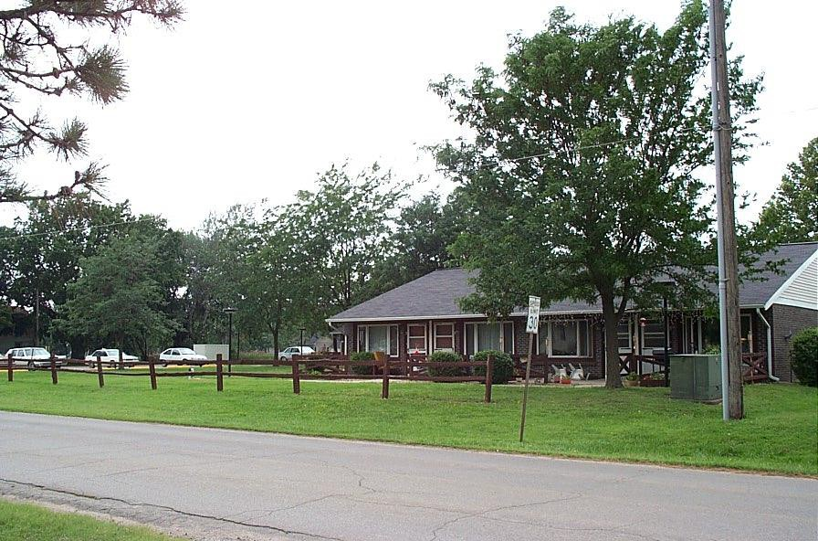

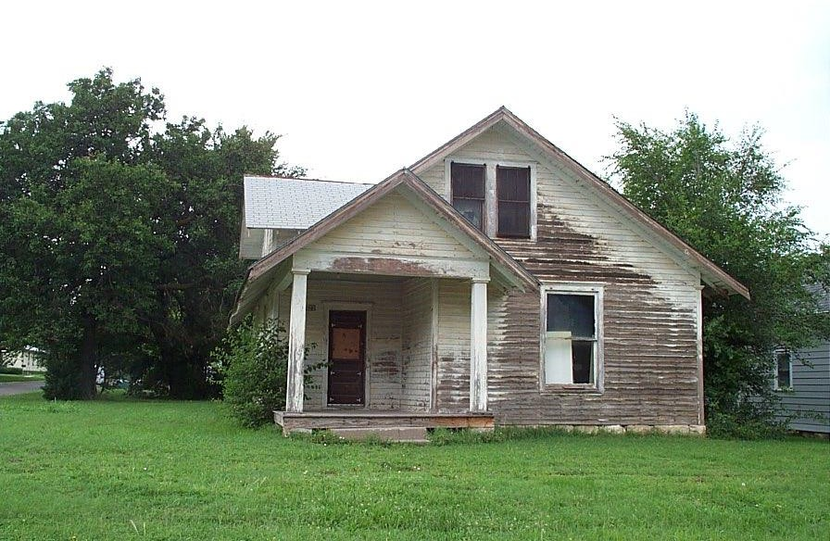

Age, Size and Condition
Over 87 percent of the housing in Herington was built prior to 1950, with 1939 being the median year for all housing built in the City. There were a few homes built between 1960 and 1979, but no homes have been added to the housing stock since 1980 which is most likely due to the continued decrease in population and increase in vacancy rates of existing housing
Year Housing Structure Built
60%
53%
50%

40%
34%
30%

20%
9%
10%
0%
3%
0%
0%
1939 or
earlier
1940-1949
1950-1959 1960-1969 1970-1979 1980-1989

The average units per dwelling in 1990 were 5.4 rooms, with the majority (52 percent) having 2 or less bedrooms.

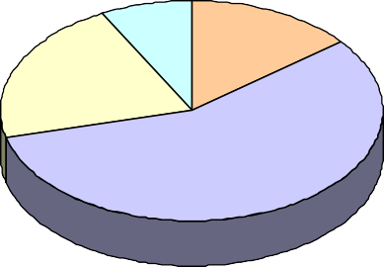
A safe, secure and affordable living environment serves as a catalyst for many factors which lead to a high quality of life in rural communities. According to the citizen survey, 96 percent of the respondents were very satisfied or satisfied with their home. Over 71 percent indicated that they felt the housing stock in Herington was either adequate or very adequate.
Condition of Housing Stock
8% 14%

21%

57%
Very Adequate Adeqate Inadequate Very Inadequate

As part of Herington’s 1998 CDBG application, a housing analysis was completed to determine the quality of the existing housing stock. There were 241 housing units determined as deteriorating, with 73 percent of those owner-occupied units and 27 percent renter-occupied. Thirty-four units were defined as dilapidated, with 33 percent owner-occupied and 66 percent renter-occupied.

One way to determine housing quality is to use the presence of complete plumbing as an indicator of the incidence of substandard housing. In 1990, 96
Source of Water |  | Sewage Disposal
Public or private | 96% | Public sewer | 98%
Drilled well | 3% | Septic tank | 1%
Dug well | 1% | Other | 1%

percent of the housing units were on the public water system while 98 percent were on the public sewer.

Goals and Objectives
Goals and objectives for issues related to housing are listed below. For a description of actions and benchmarks, refer to Section 9: Implementation and Action Plan.

Goal 1: Ensure the preservation of existing housing stock in Herington.

Objective 1: Assess, identify and prioritize community housing needs.

Objective 2: Reduce visual blighting influences upon the residential portions of Herington.

Objective 3: Increase awareness of affordable housing opportunities in the Hilltop Facility.

Objective 4: Require all residential, existing and new construction to follow required building and construction codes.

Objective 5: Utilize redevelopment actions and code enforcement to demolish and clear abandoned, blighted residential structures that constitute a public safety hazard.

Objective 6: Establish neighborhood associations which promote and assist homeowners in improving the condition of their property; promote interaction among groups.

Goal 2: Provide a variety of housing opportunities which promote the quality and character of Herington.

Objective 1: Ensure an adequate supply of high quality housing in a broad range of prices.

Objective 2: Investigate alternative financing methods to expand housing opportunities and to maintain and improve housing stock in Herington.

Objective 3: Provide opportunities for a variety of housing types including multi-family apartments, duplexes/quadplexes as well as small- and large-lot single family residences.

Objective 4: Ensure compatible land uses adjacent to residential areas.

Objective 5: Encourage infill housing so that it does not have harmful effects upon the surrounding neighborhoods.

Community Facilities and Services
  - Introduction
Developed land must have access to a network of community facilities and services necessary for the operation, minimum health and safety, and desired quality of life in urbanized areas. Generally the term infrastructure refers to water and sewer facilities, streets and sidewalks, and highways while the term community facilities refer to schools, parks and actual facilities visited by citizens. For the purpose of this section, the term “community facilities and services” includes infrastructure, citizen- serving structures, and community services provided.

Community facilities and services are important to a community’s overall quality of life. The purpose of this section is not to provide an engineering analysis of community facilities and services, but to provide a general overview and identify any important issues that warrant further analysis and recommendations.

Capital Project Plan
The City of Herington utilizes a Capital Project Plan (CPP) for the purpose of fiscal planning. The CPP is organized by department, and reflects the capital expenditures needed to ensure completion of planned projects. At present, the CPP reflects a continued need to improve the water, sewer and electrical distribution and streets infrastructure. The City Manager and Department Heads establish the CPP through a cooperative effort. This process involves identifying and prioritizing projects and the requisite materials and supplies needed to complete these projects. Typically, projects exceed one year’s budget authority. As such, projects are split into logical phases, and the expenditures needed to complete these projects are then divided within the CPP to meet expected departmental capital outlay budgets. The Capital Project Plan is then reviewed and approved by the City Commission.

City Hall
74% of survey respondents feel that the City is doing a good job of keeping them informed.
The Herington City Hall is composed of approximately 3,000 square feet. The facility itself was originally a bank, and is now jointly used by the City of Herington and U.S.D. 487. Five full time staff utilizes the space that is City Hall. It is located in the downtown area, and offers convenient access to citizens and
customers. City Hall offers meeting and storage space that is also shared by the City and U.S.D. 487.

City Library
The Herington Library is a 1500 square foot facility, located in the downtown area. It was established in 1917 through a grant from the Carnegie family. The Library is staffed by three part time employees, and offers roughly 40 business hours to the general public per week. The current book collection is approximately 15,000 books, and the staff offers summer and winter reading programs for students and day-care aged children. The City of Herington provides the Library with 7 mills from the annual budget, and it is governed by a seven member board appointed by the Herington City Commission.

Schools
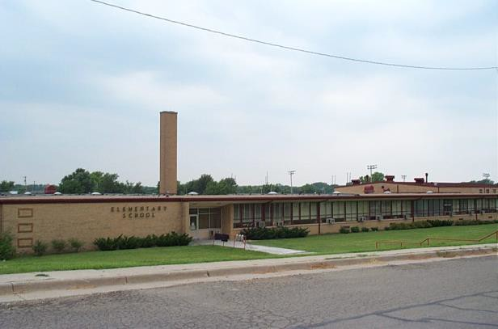
U.S.D. 487 serves approximately 550 students within a 93.7 square mile school district. The district operates on a $3.5 million budget with 55 certified personnel (teachers and administrators) and 40 classified staff (support, maintenance staff, etc.).
U.S.D. 487 is also an active participant in the “Teen Network” which is a cooperative learning environment sponsored by five other school districts in the immediate area. This allows the five participating districts to share teachers and offer classes in a digital network to students without having to bus them to other locations.

Health Care Facilities
The Herington Municipal Hospital provides full-service medical services to the greater Herington area. The Hospital operates on a $4.2 million budget with approximately 75 full-time employees. Services provided include an Emergency Room, laboratory services, an M.R.I. machine, physical, occupational and speech services as well as two family practice doctors, one surgeon and 25 beds. The Hospital is governed by an elected board of Directors that serve three-year terms.

Park and Recreation Facilities
86% of survey respondents had visited the City Park or cemetery within the last 6 months.
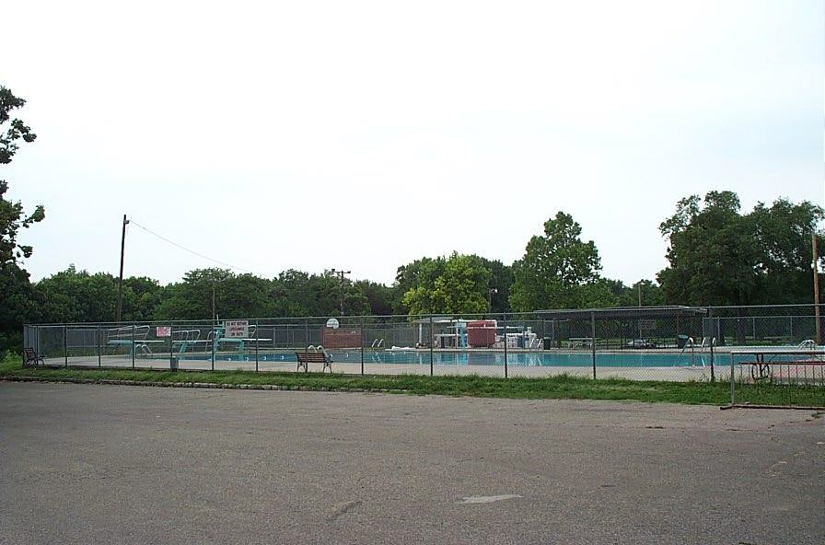
The City of Herington enjoys two parks located on the north and south sides of town. The south park hosts three baseball/softball fields, soccer fields and limited playground equipment.

It is owned by the City of Herington and maintained by the Herington Recreation Commission. The north park is home to significant playground equipment, the municipal swimming pool, Father Padilla Lake and one softball field. Father Padilla pond was reconstructed in the summer of 2000, and
serves as a centerpiece of the community. It is fully stocked with various species of fish, and is reserved for fishing for citizens under the age of 12.

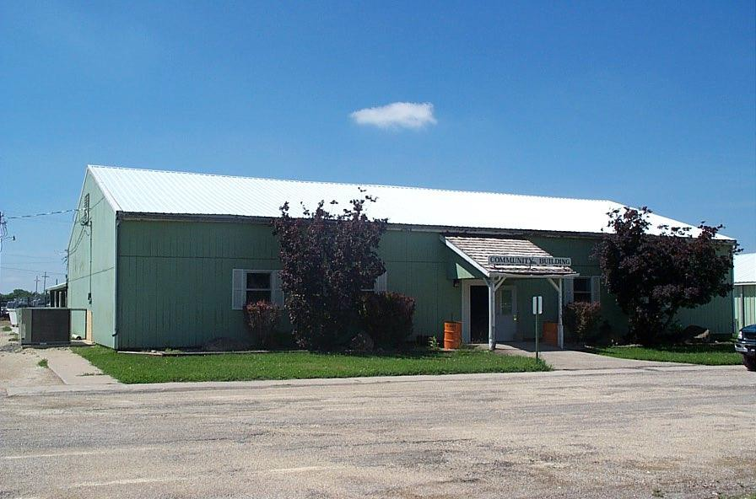
The City of Herington also offers a 12,000 square foot Community Building that is regularly used for wedding receptions, family reunions and trade shows. It is air- conditioned and offers users a full kitchen. The Community Auditorium is also available for community and school district performances of various kinds.

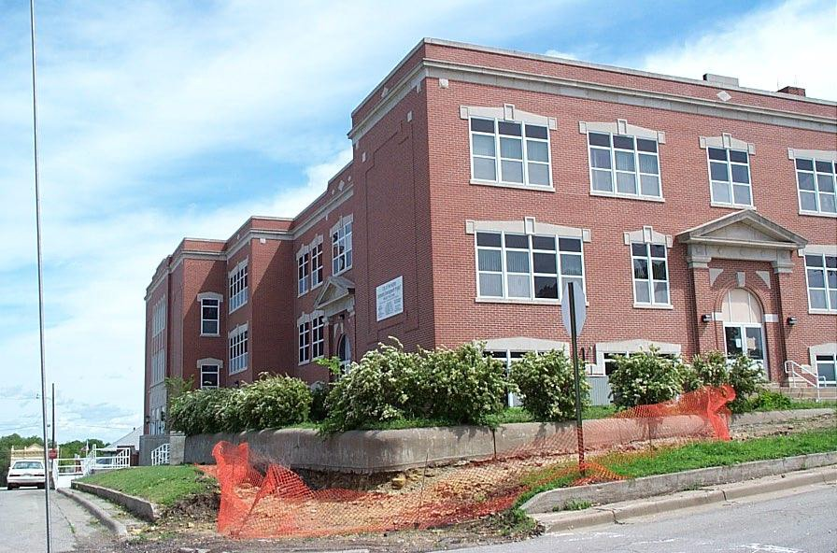
This facility is located within the Hilltop Building, which was a Middle School. In 1998, the City of Herington obtained this building a obtained a CDBG grant from the Kansas Department of Commerce Housing to renovate the classrooms into low to moderate-income apartments. Recreational space was also included in the basement floor. At present time, the Auditorium is
undergoing renovation to include the addition of heating, ventilation and air conditioning and aesthetic improvements. An official grand opening will occur in October of 2001.

Finally, the City of Herington owns and maintains two lakes located approximately 3 miles west of town. The Herington Lake is composed of 367 acres of surface water. It offers over 35 camping spaces equipped with electricity. The Herington Reservoir is composed of 555 acres of surface water, is also home to over 35 camping spaces. Both lakes are available for fishing and water sports.

Water
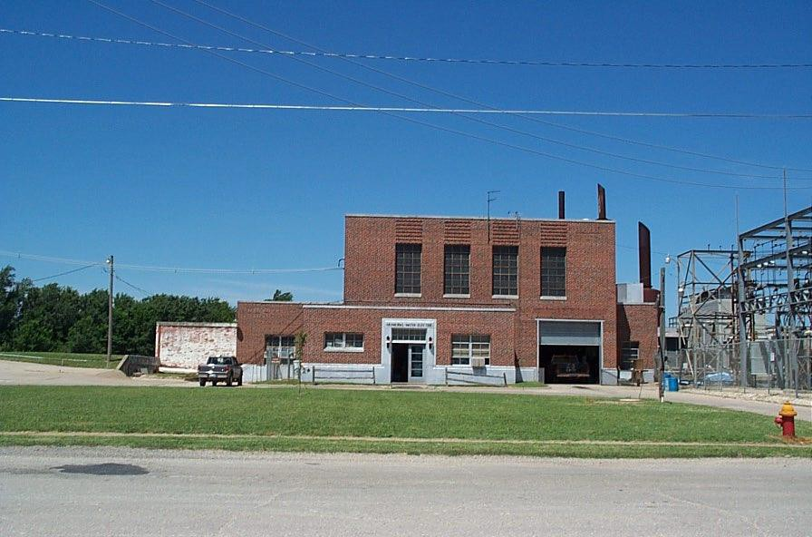
The Herington community receives its water from the Herington Reservoir. The Herington Water Plant is built to treat 950,000 gallons per day, however the average daily usage hovers around 400,000 to 500,000 gallons per day. The water distribution system is composed of two water towers (500,000 and 200,000 gallons) and approximately 120,000 linear feet of water line.

Electricity
The City of Herington provides its own electricity for the community. During the months of September through June, the City of Herington purchases electricity from Western Resources at a cost of 2.2 cents per kilowatt hour (kw/h). Between

the months of June 15 to September 15, the City of Herington utilizes a supplemental generation agreement with Western Resources which allows City staff the option of either producing it ourselves, or purchasing electricity (as available) at prices offered from Western Resources.

The total capacity of the generation equipment available at the Herington Light Plant is 7,300 kilowatt. A typical daily usage will range between 4,500 to 5,000 kilowatts.

Wastewater
The Herington Wastewater treatment plant is capable of processing 3 million gallons per day (mg/d). Averages flows hover around 800,000 mg/d. The City is currently in the process of designing and building an ultraviolet treatment system to meet the standards of our current wastewater permit. This project will be completed in March of 2002.

As with the water distribution system, the wastewater distribution system is composed of approximately 120,000 linear feet of sewer lines. The biggest problem the City faces is infiltration. Continued sewer line replacement efforts will help resolve this problem.

Fire Services
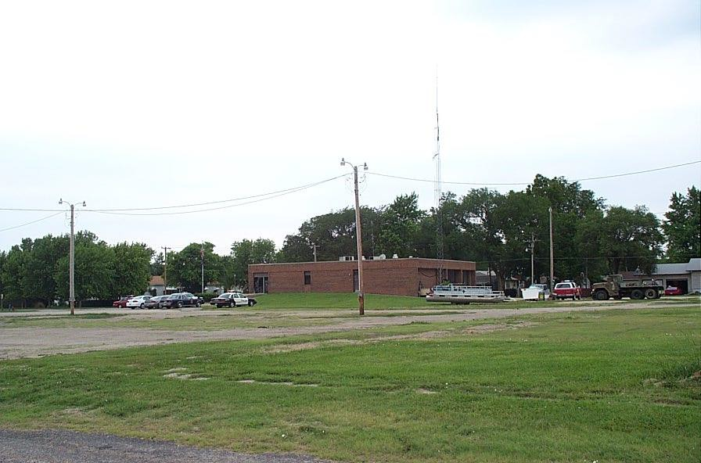
The Herington Fire Department is staffed by one full-time Fire Chief, one full-time firefighter and approximately 25 volunteers. The fire department has at its disposal three apparatus capable of fighting structural fires, three brush trucks, one water tender and two rescue vehicles. The City of Herington also provides fire services to six surrounding townships, for a total fire service coverage area of 96 square miles.

Police Services
The Herington Police Department is composed of one Police Chief, and five full-time Police Officers. The Police Department also includes a 24-hour emergency communications system (9- 1-1 service), staffed by five full-time

dispatchers. Vehicle upgrades have ensured that the City of Herington is providing quality community policing services as each Police Officer is afforded a police vehicle.

Street Maintenance
The City’s street maintenance program will be the most important aspect of day-to-day activity over the next five years. Herington’s streets are in poor condition compared to other cities of the same
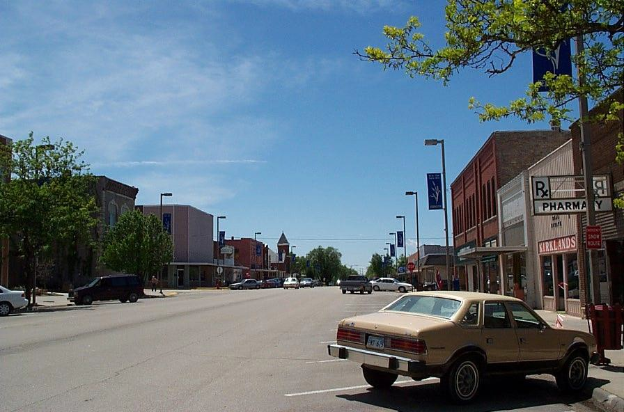
size. The city’s street maintenance budget has averaged $75,000 per year over the last two years. However, deferred maintenance practices have placed the quality of the streets in a position where that amount is not enough to repair and replace the streets fast enough. In 2000, the citizens of Herington passed an additional ½ cent
sales tax for various community improvements. One element of these improvements was the streets, and over 50 blocks of streets will be replaced in 2001. This effort will assist with improving those streets with replacement costs in excess of $100,000.

Solid Waste Disposal
The City of Herington contracts with M&K Trash for solid waste disposal services.

Recycling Program
Dickinson County recently received a grant from the Kansas Department of Health Environment to provide mobile recycling trailers for the communities. As such, a recycling trailer that accepts six types of recyclables is present in the community on the first and fourth Saturdays of each month.

Survey Results
According to the citizen survey, fire protection, quality and care of City parks and cemetery, and the quality of the City’s water service received the highest ratings for satisfaction. Conversely,

Herington citizens rated the quality of streets and maintenance, the City’s economic development efforts, and management of City services and employees as in most need of improvement.
Community Facilities and Services Ratings
July 2001 Citizen Survey
Quality of fire protection, including codes enforcement Quality and care of cemetery and parks Quality of City's w ater service
Quality of police protection Quality of City's electrical services Quality and care of community building Quality of City's sew er service
Quality and care of City lakes Quality and care of City pool
Management of City services and employees

City's economic development efforts
4.22
4.05
3.82
3.79
3.65
3.64
3.58
3.49
3.13
2.88
2.60
Quality of streets and street maintenance program
2.03
1.00 1.50 2.00 2.50 3.00 3.50 4.00 4.50 5.00
1 = Low est rating 5 = Highest Rating

Lowest Rating
Highest Rating

Community Facilities and Service | 1 | 2 | 3 | 4 | 5 | Average
Quality of streets and street maintenance program | 40% | 27% | 21% | 6% | 6% | 2.03
City's economic development efforts | 15% | 18% | 38% | 16% | 13% | 2.60
Management of City services and employees | 4% | 8% | 26% | 28% | 34% | 2.88
Quality and care of City pool | 0% | 1% | 13% | 37% | 49% | 3.13
Quality and care of City lakes | 2% | 5% | 11% | 44% | 39% | 3.49
Quality of City's sewer service | 2% | 2% | 20% | 32% | 45% | 3.58
Quality and care of community building | 1% | 3% | 12% | 25% | 59% | 3.64
Quality of City's electrical services | 3% | 7% | 18% | 35% | 37% | 3.65
Quality of police protection | 5% | 4% | 15% | 30% | 46% | 3.79
Quality of City's water service | 3% | 7% | 15% | 29% | 47% | 3.82
Quality and care of cemetery and parks | 1% | 2% | 14% | 40% | 44% | 4.05
Quality of fire protection, including codes enforcement | 0% | 1% | 12% | 27% | 60% | 4.22

Goals and Objectives
Goals and objectives for issues related to community facilities and services are listed below. For a description of actions and benchmarks, refer to Section 9: Implementation and Action Plan.

Goal 1: Encourage the utilization of existing community facilities.

Objective 1: Promote awareness and usage of all community facilities

Goal 2: Provide general community information and awareness for Herington

Objective 1: Increase community awareness, for visitors and residents.

Goal 3: Provide awareness of the adequacy of community facilities and infrastructure which meet the existing and future needs of Herington.

Objective 1: Achieve an improved municipal understanding of what infrastructural needs exist.
Objective 2: Determine financial remedies for the improved operation of the community healthcare facilities.

Goal 4: Promote and improve the Interaction of the community’s youth.

Objective 1: Establish meaningful opportunities for the community’s youth to interact with local government.

Economic Conditions
  - Introduction
The strength of a city’s economy is important to the current and future well-being of its residents. Economic activity within a community has a significant impact on quality of life and the future viability of a city. As such, it is important to understand the economic dynamics of a community to assess its current and future vitality and implement measures to ensure that economic

Local level economic data for a city of under 2,500 residents is often difficult to obtain and interpret. For this reason, economic data for Dickinson County has been collected and analyzed in addition to data for the City to determine any relevant trends or movements in the local economy. Economic data for this section was collected mainly from the 1980 and 1990 US Census of Population, the Bureau of Labor Statistics, the Kansas Department of Human Resources, the Policy Research Institute at the University of Kansas, the Economic Census, and the 1999 Situations and Trends Report for Dickinson County. Additional economic data was obtained from a Trend Profile Report produced by CACI, one of the nation’s premier demographic forecasting company’s. Other data was collected from the City Manager’s office and through field studies and observation. Note: At the writing of this plan, the 2000 Census results are being tabulated. Information on the local level will be available sometime in mid-2002. It is highly recommended this section be updated with 2000 Census data when it becomes available.

Employment
Employment is an important determinant of population growth and change, as well as a direct source of demand for space, community facilities and services, and natural resources.
1990-1997: Percent Increase in Employment
10.0%
8.9%
8.0%

6.0%
5.7%
4.0%
2.6%
2.0%

0.0%
Dickinson County
Ks. County Average
State of Kansas

The Kansas economy, like the nation’s, has been generally been strong in the
1990s. Mining, farm, and finance, insurance & real estate employment declined 21.1, 5.9, and 4.1
percent respectively between 1990 and 1996. But employment in other industries grew significantly: construction (33.6 percent), agricultural services (25.1 percent), services (18.4 percent) and retail

trade (17.9 percent). Employment in the remaining industries also showed solid growth: wholesale trade (7.6 percent), manufacturing (6.4 percent), transportation (5.7 percent), and government (5.4 percent).
Employment by Industry
35%
29%
30%
26%
25%
20%
20%
17%
21%
20%
20%
20%
17%
18%
19%
18% 15%
16%
17%
15%
11%
13% 12%
10%
8%
5%
5% 5%
4%
6%
5%
5%
6%
5%
4%
4%
6%
4% 4%
0%
Herington Dickinson Kansas County Average State of Kansas

In 1997, Dickinson County’s total employment was 9,735, and the Kansas county average was 12,522. Between 1990 and 1997, Dickinson County’s total employment increased 8.9 percent, from 8,943 to 9,735. The Kansas county average over the same period increased 2.6 percent to 12,522, while the state total increased 5.7 percent. Of 105 counties, 54 had an increase in total employment over this period.

Almost half (47%) of the employees in Herington were employed in service or retail oriented businesses. Nineteen percent were employed in transportation, communications and public utilities, indicating the presence of Union Pacific Railroad as one of the major employers in the community. When compared to Dickinson County, Kansas County Averages, and the State of Kansas, Herington has a relatively higher proportion of employees employed in transportation, communications and public utilities and wholesale trade and a relatively lower proportion of employees employed in public administration and agriculture.

Place of Work
The majority of employed persons in Herington worked traveled less than 8 minutes to their place of employment, indicating that most were employed within the City limits. However, thirty percent of employed persons traveled more than 30 minutes to work indicating that some
Travel Time to Work
50%
40%
40%

30%
21%
20%
14%
14%
9%
10%
2%
0%
Less than 5 5 - 9 minutes 10 - 19 20 - 29 30 - 39 40 minutes + minutes minutes minutes minutes
residents were commuting to jobs in other locations, most likely Junction City, Salina or Topeka.

Unemployment
For the purpose of this analysis, unemployment rates were calculated and compared for Dickenson County, the Saline-Ottawa Labor Market Area (LMA), the Riley-Geary-Pottawatomie Area LMA, the State of Kansas, and the United States. Unemployment rates across all geographic boundaries have been decreasing over the past 15 years, generally following the trend in national unemployment. The unemployment rate in Dickinson County has typically been one of the lowest when compared to similar populous counties throughout the State. In 2000, Dickinson County’s average annual unemployment rate was 3.0 percent, indicating that the County was virtually at full- employment.
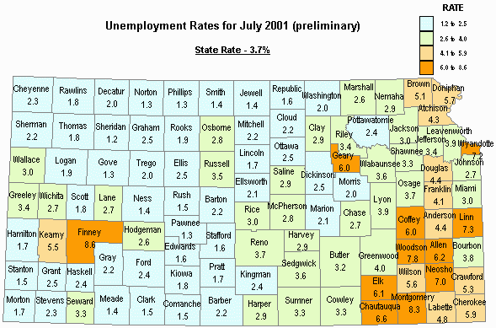
Map Source: Kansas Department of Human Resources

 | Unemployment Rate
12.0%
10.0%
8.0%
6.0%
4.0%
2.0%
0.0%
 | 1976 1977 1978 1979 1980 1981 1982 1983 1984 1985 1986 1987 1988 1989 1990 1991 1992 1993 1994 1995 1996 1997 1998 1999 2000 2001
Dickinson | 3.0% 3.0% 2.5% 2.7% 4.3% 4.5% 7.5% 7.1% 6.2% 5.6% 5.9% 5.1% 4.6% 3.6% 3.8% 4.0% 3.4% 4.5% 5.0% 5.6% 5.3% 4.2% 3.3% 2.8% 3.0% 3.4%
Riley Geary LMA | 5.3% 6.0% 4.6% 5.1% 5.5% 4.8% 4.8% 4.6% 4.5% 3.3% 4.0% 4.0%
Saline-Ottow a LMA | 4.2% 3.8% 3.4% 4.1% 3.8% 4.0% 3.9% 3.7% 3.5% 2.5% 2.8% 3.1%
Kansas | 4.2% 4.1% 3.0% 3.4% 4.5% 4.2% 6.3% 6.1% 5.2% 5.0% 5.4% 4.9% 4.8% 4.0% 4.5% 4.5% 4.3% 5.0% 5.3% 4.4% 4.5% 3.8% 3.8% 3.0% 3.7% 3.8%
United States | 7.7% 7.5% 6.7% 5.9% 7.2% 7.6% 9.7% 9.6% 7.5% 7.2% 7.0% 6.2% 5.5% 5.3% 5.6% 6.9% 7.5% 6.9% 6.1% 5.6% 5.4% 4.9% 4.5% 4.2% 4.0% 4.4%
 |  | Dickinson Riley Geary LMA Saline-Ottowa LMA Kansas United States

Economic Base
The economic base in the North Central region of Kansas consists of primarily of health care, education and the retail sectors. Herington’s economic base consists of agriculture, retail, small manufacturing, transportation and service and agriculture businesses.
1997 Economic Census | No. of Establishments
 | Dickinson | Herington
Manufacturing | 25 | NA
Wholesale trade | 25 | 2
Retail trade | 110 | 27
Real estate, rental and leasing | 10 | 1
Professional, scientific, and technical services | 24 | 2
Administrative and support | 11 | 2
Health care and social services | 35 | 8
Arts, entertainment, and recreation | 15 | 1
Accommodation and foodservices | 49 | 9
Other services | 37 | 7

50% |  |  | No. of Establishments as a Percentage  46%  32%  14%  7% 7% 10%  3% 3% 2% 3% 3%3% 4% 2%
40%
30%
20%  10% | 7% |  |  |  |  |  | 15%  14% | 11% | 12%
 |  | NA
0%
 |  |  |  | Dickinson | Herington

When considering the number of businesses, 60 percent of Herington’s business establishments are in the health care or the retail sector. The healthcare and retail sectors also generate substantial payroll in the

local economy, paying its employees over $2,000,000 per year in 1997.

Wages
In 2000, the average wage paid for all industries was $19,358 in Dickinson County. Occupations in the Transportation and Public Utilities paid the highest average salary ($37,207) while the service industry paid the least ($16,608).
$40,000
$35,000
2000 Average Wages by Industry
$37,207
$30,000
$25,000
$20,000
$15,000
$10,000
$5,000
$-
$19,358
$25,156
$20,775
$26,513
$19,166 $18,993
$22,688
$19,078
$16,608
$20,041
$14,357

  - Occupational Outlook According to the Kansas Department of Human Resources, employment in North Central Kansas¹ is expected to grow 11.9 percent from 1996 to 2006. The services industry will lead in job creation with 19.8 per cent growth while the agriculture industry is expected to experience the only decline with a 19.5 per cent drop in employment.
Occupational Outlook: 1996-2006
25.0%
19.8%
20.0%
15.4%
15.8%
15.0%
13.4%
13.9%
13.5%
14.4%
11.0% 10.2%
10.0%
10.0%
7.8%
5.0%

0.0%

-5.0%

-10.0%

-15.0%

-20.0%
-19.5%
-25.0%

¹ North Central Kansas includes the following counties: Cloud, Dickinson, Ellsworth, Jewell, Lincoln, McPherson, Mitchell, Marion, Morris, Ottawa, Reno, Republic, Rice, and Saline. Source: Kansas Department of Human Resources.

Industry | Avg. Annual Employment 1996 2006 |  | Total Change  Actual Per Cent
Agriculture | 10,780 | 8,680 | -2,100 | -19.5%
Mining | 510 | 550 | 40 | 7.8%
Construction | 4,440 | 4,930 | 490 | 11.0%
Manufacturing | 19,540 | 21,540 | 2,000 | 10.2%
Transportation, Communication and Public Utilities | 4,190 | 4,750 | 560 | 13.4%
Trade, Total | 28,040 | 32,350 | 4,310 | 15.4%
Wholesale Trade | 6,340 | 7,220 | 880 | 13.9%
Retail Trade | 21,700 | 25,130 | 3,430 | 15.8%
Finance, Insurance, and Real Estate | 3,930 | 4,460 | 530 | 13.5%
Services | 34,390 | 41,210 | 6,820 | 19.8%
Government | 8,500 | 9,720 | 1,220 | 14.4%
Self Employed and & Unpaid Family Workers | 11,420 | 12,560 | 1,140 | 10.0%
Total | 126,880 | 141,940 | 15,060 | 11.9%

Industry employment projections for North Central Kansas indicate the strongest growth in service- producing industries. In 1996, service-producing industries employed 69.2 per cent of the North Central Kansas employment, with goods-producing industries representing 30.8 per cent. It is
projected that by 2006, 72.2 per cent of working North Central Kansans will be employed in service-producing industries with only 27.8 per cent employed in goods-producing industries.
North Central Kansas Employment by Industry Sector

80.0% 69.2% 72.2%
70.0%

60.0%

50.0%

40.0% 30.8% 27.8%
30.0%

20.0%

10.0%

0.0%
1996 2006

Goods Producing Service Producing
Top Ten Occupations adding Jobs in North  Central Kansas | Avg. Annual Employment |  | Change
Occupational Titles | 1996 | 2006 | Actual | %
Cashiers | 3,260 | 3,990 | 730 | 22.4
Salespersons, Retail | 3,280 | 3,990 | 710 | 21.6
Nursing Aides & Orderlies | 2,060 | 2,640 | 580 | 28.2
General Mgrs & Top Execs | 3,230 | 3,710 | 480 | 14.9
Registered Nurses | 1,740 | 2,200 | 460 | 26.4
Marketing/Sales Supervisors | 1,990 | 2,300 | 310 | 15.6
General Office Clerks | 2,550 | 2,860 | 310 | 12.2
Hairdressers & Hairstylists | 2,720 | 3,010 | 290 | 10.7
Food Preparation Workers | 1,290 | 1,570 | 280 | 21.7
Comb Food Prep/Service Workers | 1,450 | 1,730 | 280 | 19.3
Total | 23,570 | 28,000 | 4,430 | 18.8

Registered nurses and nursing aides and orderlies will experience the greatest growth in the region, increasing by over 54 percent and adding over 1,000 jobs. Cashiers and retail salespersons will add the most jobs out of this group. These two occupations combined will add 44.0 per cent, or 1,440 of the new jobs in service occupations. The occupation of registered nurses is the only professional, paraprofessional and technical occupation on the list.

An occupation must have at least 1,000 in employment and show a decrease in employment from 1996 to 2006 to be considered a declining occupation. The first four occupations listed are in agriculture, the industry most consistently declining across the state. As workers become more productive with advances in technology and automation in office functions, there will be a reduction in
Major Declining Occupations in  North Central Kansas | Avg. Annual Employment |  | Change
Occupational Titles | 1996 | 2006 | Actual | %
Farm Equipment Operators | 2,280 | 1,790 | -490 | -21.5
Farm Workers | 2,220 | 1,730 | -490 | -22.1
Agriculture, Fishing | 2,560 | 2,100 | -460 | -18
Farm Managers | 1,390 | 1,170 | -220 | -15.8
Bookkeeping, Accounting,  Audit Clerks | 2,230 | 2,150 | -80 | -3.6
Secretaries | 2,180 | 2,100 | -80 | -3.7
Total | 12,860 | 11,040 | -1,820 | -14.2

demand for bookkeeping, accounting, audit clerks and secretaries.

Local Economic Development
Herington has a local chamber of commerce that receives funding through membership dues and through an appropriation from the City’s general budget. Herington has implemented a Main Street Program to encourage preservation and development within the Downtown District. Downtown Herington is a traditional retail center and the primary convenience commercial district of the tri- county area which includes a primary trade area of a 20 mile radius. It contains a great concentration of independent retail establishments and offers a unique shopping experience for residents and visitors. Due to its unique architecture, small village character, and mixed-use dynamic, downtown Herington exhibits the fundamental characteristics of new urbanist ideals which are very marketable and practical for rural economic development.

Rural Economic Growth
According to a recent Economic Service Research Report commissioned by the USDA², local areas that are attractive places to live for non-economic reasons, that have low labor costs, and that have fewer people receiving government transfer payments show
Policy factors
- Taxation
- Public spending
- Public capital stocks
- Branch banking laws
- Availability of industrial-revenue bond financing

Non-policy factors
- Wage levels
- Unionization levels
- Unemployment levels
- Labor force quality (measured by education)
- Proximity to higher education institution
- Access to highways, airports, and other transportation
- Proximity to metropolitan area
- Per capita or family income
- Population size and density
- Urbanization
- Minority population concentration
- Temperature and precipitation
- Energy prices
- Industry mix or concentration
- Availability and price of land
- Labor productivity
- Local fire protection ratings
- Small business activity measures
- Population age distribution measures
Factors that may affect rural economic growth:
clear economic advantages over other places. However, it should be noted that most variation in growth is accounted for by other factors including regional trends and the industrial composition of employment.

Economic development strategies and expectations for their success also need to take into account such unquantified local factors, which are likely to include some of the greatest advantages and handicaps of local areas.

Policy and non-policy factors that may affect local economic growth are listed in the table to the right. When formulating an effective economic development plan for Herington, these factors should be studied in detail. Any that give Herington an economic advantage should be promoted for increased economic development in the area.

² “Rural Economic Development: What Makes Rural Communities Grow?”, Agriculture Information Bulliten No. 737, September 1997, USDA.

Goals and Objectives
Goals and objectives for issues related to economic development are listed below. For a description of actions and benchmarks, refer to Section 9: Implementation and Action Plan.

Goal 1: Expand the City’s economic base by attracting new businesses.

Objective 1: Identify economic development opportunities associated with the Herington Regional Airport.

Objective 2: Encourage the participation of Herington Industrial and Commercial Development Inc. (HICD) in the economic development endeavors identified in this plan.

Goal 2: Support economic growth through tourism, by capitalizing on nearby visitor destinations, and proximity to larger City’s throughout Kansas.

Objective 1: Increase retail shopping activity in Herington.

Objective 2: Preserve and maintain the integrity and character of the downtown business district.
Objective 3: By promoting tourism and cultural development, increase the number of visitors to the City.

Goal 3: Expand the City’s economic base by supporting the retention and expansion of existing businesses.

Objective 1: Develop a program to assist local businesses with their expansion and retention needs.

Implementation

Introduction

The Herington Comprehensive Plan defines goals and objectives which address issues deemed most important for the future development of the community. It is important to understand that the Plan by itself will not accomplish much without a dynamic implementation framework. This section outlines an implementation framework through which the goals and objectives can be accomplished in the future.

Implementation Framework

Implementation of the Herington Comprehensive Plan emphasizes self-reliance, partnership and accountability. The success of implementation depends on the initiative of City staff, elected officials, local organizations and institutions, and most importantly, local citizen participation. The plan must be perceived as a capable tool in guiding the City’s future and it must be continually referenced in planning and zoning reports as well as in discussion sessions regarding city matters.
The implementation framework is outlined in the Action Plan Matrix at the end of this section and addresses land use and zoning, housing, community facilities and services and economic development. Actions are defined to achieve related goals and objectives. Benchmarks have been assigned to gauge the effectiveness of each action.
Implementation of the Herington Comprehensive Plan is based on the following principles: Feasibility: Implementation of the plan is based on reasonable limits of feasibility, involving an understanding of public awareness and support, public and private administrative capabilities, and the limits of public and private funding.

Incrementalism: Implementation of the plan will occur incrementally, allowing for subsequent changes to adapt to changing information and emphasis. The incremental approach ensures flexibility in the future in case of changing conditions.

Evaluation of the Comprehensive Plan

The planning process is a continuous one. As such, the Plan should be monitored and updated when necessary. The City Manager, Planning Commission and City Council should carefully review proposed changes and their implications and actively seek citizen comment on such proposals. If changes are found appropriate, they should formally be added to the plan as a legal amendment. According to Kansas State Statute,
“…at least once each year, the planning commission shall review or reconsider the plan or any part thereof and may propose amendments, extensions or additions to the same. The procedure for the adoption of any such amendment, extension or addition to any plan or part thereof shall be the same as that required for the adoption of the original plan or part thereof.”¹
At five year intervals the Comprehensive Plan should be reviewed and modified to ensure that it continues to be a current expression of community goals and objectives. In addition to a five year review, the following process is recommended for plan evaluation:
Annual Action Agenda: The City Manager will prepare an annual action agenda of tasks and benchmarks to be accomplished each year based on the Action Plan. The City Manager will present an annual action agenda to the Planning Commission and to City Council for approval at least 45 days prior to each new fiscal year. The purpose of the annual action

¹ K.S.A. Chapter 12, Article 7, Sections 12-747 – 12-760.

agenda is to implement a manageable part of the plan, involving the necessary parties involved in that action, and to provide necessary resources to fulfill implementation.
Annual Status Report: The City Manager will prepare an annual status report to which identifies what has been accomplished according to the annual action agenda. This will allow City staff to track what is being implemented and will provide the means to let City Council know each year what has been accomplished.
Update the Plan: Although amendments and changes may be added to the plan over the course of the next five years, it is recommended that the City conduct a completed update of the Plan in the year 2007. Reinitiating the process for the 2007-2012 time frame will allow the City to address any new or different issues facing the community at that time.

Implementation Management

The City Council, the Planning Commission and City Staff should use the plan to support their decisions and actions. Because the City does not have a planning department to help facilitate the planning process and monitor plan implementation, it is recommended that the City Manager act as the primary point of contact. The City Manager will be able to delegate implementation activities to appropriate staff when necessary. He will also be able to engage the appropriate parties regarding different implementation actions on an annual basis.

Action Plan

The Action Plan for implementation activities is located on the following pages.

Appendix 1 – Action Item Matrices

COMMUNITY FACILITIES AND SERVICES

Goal | Objective | Action Item/ | Benchmarks
Goal 1: Encourage the utilization of existing community facilities. | Objective 1: Promote awareness and usage of all community facilities | - Apply for Kansas Department of Commerce and Housing’s CCB program implementation grant to design a community website to increase regional awareness of all community facilities.  - Design a community facilities brochure and send to targeted market including state and federal agencies.  - Encourage local civic organizations to conduct meetings utilizing existing community facilities.  - Increase regional awareness of the opportunities for community utilization for the Hilltop Facility.  - Integrate the Hilltop Facility into a community facilities brochure in increase awareness of the amenities in this facility.  - Encourage various elected bodies to conduct meetings away from City Hall on a periodic basis to increase exposure to community facilities.  - Contact state and federal agencies about utilizing Herington’s community facilities for regional meetings.  - Utilize KDCH’s “Attraction and Development” Grant Program to maintain and improve the Hilltop Auditorium Facility to promote it’s potential as a tourist venue | - Apply for funds for FY 2002.  - Complete brochure design by end of first quarter 2002 and begin marketing campaign by end of second quarter 2002.  - Book 6 new events at the community center in 2002
 |  |  | - Complete brochure design by end of first quarter 2002 and begin marketing campaign by end of second quarter 2002.
 |  |  | - Contact at least three state agencies about state and regional meetings before the end of the first quarter in 2002.
 |  |  | - Apply for funds for FY 2002.
Goal 2: Provide general community information and awareness for Herington | Objective 1: Increase community awareness, for visitors and residents. | - Apply for Kansas Department of Commerce and Housing’s CCB program implementation grant to design a community website to increase regional awareness of all community facilities.  - Placement of City sponsored meeting notices and outcomes on local television channel 34. | - Apply for funds for FY 2003  - Engage website design entity by the end of first quart of 2002.  - Discuss with local cable/television provider the placement of community notices, etc., by end of year 2001.
Goal 3: Provide awareness of the adequacy of community facilities and infrastructure which meet the existing and future needs of Herington. | Objective 1: Achieve an improved municipal understanding of what infrastructural needs are existing.  Objective 2: Determine financial remedies for the improved operation of the community healthcare facilities. | - Re-establish a Capital Improvement Plan for all City infrastructure (street, water, sewer, electric) needs.  - Apply for Kansas Department of Commerce and Housing’s CCB program implementation grant to incorporate a Geographic Information System (GIS) with the Capital Improvement Plan.  - Investigate the possibility of consolidating grounds maintenance activities to achieve cost savings for both organizations. | - Apply for funds for FY 2004  - Research GIS capabilities by the end of the fourth quarter of 2003.  - Organize meeting with Hospital administrators by end of third quarter of 2002.
Goal 4: Promote and improve the Interaction of the community’s youth. | Objective 1: Establish meaningful opportunities for the community’s youth to interact with local government. | - Develop and appoint a joint City/School youth advisory board to obtain meaningful youth participation in the local government  setting. | - Engage School District Administration in discussions about a youth advisory board by the end of the fourth  quarter of 2002.

ECONOMIC DEVELOPMENT

Goal | Objective | Action | Benchmarks
Goal 1: Expand the City’s economic base by attracting new businesses. | Objective 1: Identify economic development opportunities associated with the Herington Regional Airport.  Objective 2: Encourage the participation of Herington Industrial and Commercial Development Inc. (HICD) in the economic development endeavors identified in this plan. | - Apply for the Kansas Department of Commerce and Housing’s CCB implementation grant to hire a consultant to assist with a redevelopment plan.  - Investigate opportunities associated with selling excess land at the Airport to create an economic development incentive fund at the site.  - Investigate the possibility of utilizing tax increment financing to provide public improvements and additional economic development incentive funds at the site.  - Investigate the possibility of applying for an Economic Development Administration (EDA) implementation grant¹  - The City should work with surrounding municipalities and County’s to initiate a regional approach to redeveloping the Herington Regional Airport  - In conjunction with HICD to identify suitable sites for economic development and promote through a coordinated economic development strategy.  - In conjunction with HICD, produce economic development package for businesses looking to locate within Herington or existing businesses.  - In conjunction with HICD, create website to promote economic development opportunities within Herington. | - Apply for grant for FY 02, application due dates are the end of September each year  - Complete land disposition and TIF study by the end of the second quarter of 2002 and submit to the City Commission  - Obtain and review EDA materials by the end of the first quarter of 2002  - Meet with surrounding communities and county’s to gauge interest in airport redevelopment by the end of the third quarter of 2002  - Identify economic development sites and develop strategy by the end of the third quarter of 2002.  - Produce marketing materials and web site by the end of the first quarter of 2003.
Goal 2: Support economic growth through tourism, by capitalizing on nearby visitor destinations, and proximity to larger City’s throughout Kansas. | Objective 1: Increase retail shopping activity in Herington.  Objective 2: Preserve and maintain the integrity and character of the downtown business district. | - In conjunction with the Herington Chamber of Commerce and Main Street program, ensure the completion of a thorough “Shop Herington” program.  - In conjunction with the Herington Chamber of Commerce and Main Street program, investigate the possibility of the creation of a Business Improvement District (K.S.A. 12-1782 et seq.) in the Main Street area to provide necessary aesthetic improvements.  - Investigate the possibility of utilizing a tax increment financing district generally bounded by Main Street on the north, “D” Street on the east, Franklyn Ave. on the south and Highway 56/5th Street on the west to offer a business improvement fund. | - Increase sales tax revenues by 3 percent  - Prepare and complete TIF and BID study by the end of the second quarter of 2002.

 | Objective 3: By promoting tourism and cultural development, increase the number of visitors to the City. | - Study a Community Assistance Grant program to devote city resources to worthwhile endeavors, and in so doing, perhaps identify THE tourism endeavor that might put Herington on the map.  - Using the Kansas Department of Commerce and Housing’s “Attraction and Development” grant, ensure that necessary  improvements are made to secure the Auditorium’s potential as a tourist attraction.  - Incorporate visitor information into the establishment of a web site. | - Complete study and provide recommendations to City Council and Chamber of Commerce by the end of the second quarter of 2002.  - Attraction and Development grants are due annually in November.  - Update web site by due date should be consistent with other action plans relating to web sites.
Goal 3: Expand the City’s economic base by supporting the retention and expansion of existing businesses. | Objective 1: Develop a program to assist local businesses with their expansion and retention needs. | - In conjunction with the Herington Industrial and Commercial Development, Inc. and the Chamber of Commerce and Main Street program, investigate the possibility of setting up a small business assistance center.  - Meet on a semi-annual basis with small business owners to address concerns and needs.  - Develop a visitation program to meet with major employers within the City to express appreciation for their business and obtain information related to future needs.  - Profile successful local businesses in the Chamber newsletter and on the City’s website. | - Complete research on the practicality of a small business assistance center by the end of the second quarter of 2002.  - Increase number of businesses requesting assistance.  - Increase number of businesses visited and assisted.  - Increase number of local businesses expanding operations.

Housing

Goal | Objective | Action Item/ | Benchmarks
Goal 1: Ensure the preservation of existing housing stock in Herington. | Objective 1: Assess, identify and prioritize community housing needs.  Objective 2: Reduce visual blighting influences upon the residential portions of Herington.  Objective 3: Increase awareness of affordable housing opportunities in the Hilltop Facility.  Objective 4: Require all residential, existing and new construction, to follow required building and construction codes.  Objective 5: Utilize redevelopment actions and code enforcement to demolish and clear abandoned, blighted residential structures that constitute a public safety hazard.  Objective 6: Establish neighborhood associations which promote and assist homeowners in improving the condition of their property; promote interaction among groups. | - Conduct a thorough assessment of Herington’s housing stock, identifying potential areas for neighborhood development grants.  - Investigate the opportunities relating to instituting a Neighborhood Revitalization program.  - Continue to allocate funds, via the City General Fund, for community nuisance abatement activities.  - Formulation of residential neighborhood associations  - Integrate the Hilltop Facility into a community facilities brochure to increase awareness of the amenities at the facility. | - Complete assessment by the end of the second quarter of 2002.  - Apply for funds for FY 2002  - Determine Neighborhood Revitalization program guidelines and applicability by the end of the fourth quarter of 2002.  - Continue general fund allocation.  - Complete brochure design by end of first quarter 2002 and begin marketing campaign by end of second quarter 2002.
Goal 2: Provide a variety of housing opportunities which promote the quality and character of Herington. | Objective 1: Ensure an adequate supply of high quality housing in a broad range of prices.  Objective 2: Investigate alternative financing methods to expand housing opportunities and to maintain and improve housing stock in Herington.  Objective 3: Provide opportunities for a variety of housing types including multi-family apartments, duplexes/quad-plexes as well as small- and large-lot single family residences.  Objective 4: Ensure compatible land uses adjacent to residential areas.  Objective 5: Encourage infill housing so that it does not have harmful effects upon the surrounding  neighborhoods. | - Enforcement of Zoning and code regulations.

LAND USE AND ZONING

Goal | Objective | Actions/Policies | Benchmarks
Goal 1: Provide for a balanced land use pattern that retains the character of the community while accommodating future growth. | - Objective 1: Locate future urban development within or adjacent to existing urban areas in order to prevent sprawl and strip development, to assure the provision of adequate urban services, to environmentally sensitive areas and open space land uses.  - Objective 2: Maintain orderly growth within the City and within a 2-mile extraterritorial area to meet necessary residential and commercial requirements consistent with the availability of city services and activities and the maintenance of a high quality of life as defined in the City vision.  - Objective 3: Encourage development which would positively affect existing, surrounding land uses.  - Objective 4: Maximize the utility of funds invested in public facilities and services to existing and future land use development | - Require the Planning Commission to investigate the existing land use and zoning documents to verify the appropriateness of set-backs, established land uses, etc.  - Adopt a future land use plan that is in accordance with the vision, goals and objectives outlined in the Comprehensive Plan and the Planning Commission investigation of existing land use.  - Maintain active working partnership with Dickinson County regarding land use and zoning issues.  - Coordinate the capital improvements plan (CIP) with the future land use map and concentrate public expenditures for infrastructure and services within areas designated for development as designated on the Future Land Use Map  - Require that the approval of new development shall be subject to the availability of adequate levels of service for roads, mass transit, potable water, sanitary sewer, solid waste, storm water management facilities and parks, as defined in the adopted level of service standards | - Complete investigation by the end of the second quarter of 2002.  - Provide the City Commission with a proposed future land use plan by the end of the third quarter of 2002.  - Ongoing  - Integration of CIP and future land use plan should occur by the end of the first quarter of 2003.  - Ongoing
Goal 2: Encourage development which positively affects existing and future surrounding land uses. | - Objective 1: Avoid abrupt changes in scale and density between residential and non-residential areas and between residential areas of different densities.  - Objective 2: Preserve the character of residential neighborhoods by encouraging new or remodeled structures to be compatible with the neighborhood and adjacent structures.  - Objective 3: Enhance the desirable characteristics of mixed-use areas throughout the City. | - Maintain the scale and character of the City by avoiding land uses that are overwhelming and unacceptable due to their size and scale.  - Prepare detailed plans on an as needed basis to address specific development opportunities and redevelopment needs. | - Ongoing  - Ongoing
Goal 3: Encourage an orderly and environmentally appropriate land use pattern which provides for the safety of existing and future residents. | - Objective 1: Protect environmentally sensitive lands, conserve natural resources, protect floodplains, maintain water quality, and open space, and conserve and protect historic and resources. |  | - Develop a community wide hazard mitigation plan.

Appendix 2: Comprehensive Plan Steering Committee

To further citizen involvement in the process, a Comprehensive Plan Steering Committee was appointed. The Steering Committee is reflective of virtually every community sector. Every government entity, city advisory board and community service group has a representative on this 24-member board. The names of the Steering Committee members and the organizations they represent are listed below:

Luella Tim – Herington Municipal Hospital Board of Directors Board of Zoning Appeals

Frank Meyer – Planning Commission
Lake Advisory Board

Bill Huggins - Hilltop Advisory Board
Herington Municipal Hospital Board of Directors Tri-County Area Arts Council
President, Tri-County Area Historical Society

Jim Roberts - Former Mayor and City Commissioner Herington Housing Authority Board

Dennis Scharenberg - Tri-County Area Chamber of Commerce/Main Street Board of Directors
President, Herington Industrial and Commercial Development, Inc. Herington Regional Airport Advisory Board

Dan Denning - Tri-County Area Arts Council
Herington Planning Commission

Rod Erickson - President, Herington Recreation Commission
U.S.D. 487 School Board

Larry Mann - City Commissioner
Tri-County Area Chamber of Commerce/Main Street Director American Legion

Vance Donahue – Mayor
Tri-County Area Chamber of Commerce/Main Street Board of Directors
Tri-County Area Arts Council Lyons Club
Kiwanis Club

Judy Peterson - Beta Sigma Phi (women’s social service organization) Debbie Wendt - City Clerk
Ruth-Ann Clarehout – Kiwanis Club
Herington Minesterial Alliance Don Sameniego - Business Owner
David Ollenberger - Former City Commissioners and Mayor
Herington Tree Board
Wilbur Smith - Chairperson, Herington Planning Commission Al Wetmore - Former Herington City Manager
Kiwanis Club

Jerry Barta - Herington Industrial and Commercial Development, Inc. David Powell – U.S.D. 487 School Board Member
Paul Barnes - Business Owner
Tri-County Area Chamber of Commerce/Main Street Board of Directors

Diana Floyd - U.S.D. 487 School Board Member Jeannie Schneider – Lake Advisory Board Georgia Rucker – Business Owner

Judy Frisbie – Business Owner
Beta Sigma Phi

Greg Wolf - Tri-County Area Chamber of Commerce/Main Street Board of Directors

Herington, Kansas Survey Results
Respondent Information
Q1: How old are you? Q2: How long have you lived in the City of Herington?
16 - 25 | 10% | Less than five years | 13%
25 - 34 | 8% | 5 to 10 years | 13%
35 - 44 | 12% | 11 to 15 years | 14%
45 - 54 | 18% | More than 20 years | 60%
55 - 64 | 9%
65 - 74 | 21%
75 or Older | 22%

Q3: How long do you plan to live in the City of Herington?
Less than 5 years 12% Between 5 and ten years 5%
10 to 20 years 2% More than 20 years 64%
Don't know 17%

Q4: Do you live in the City Limits of Herington? Q5: East or West Side?
Yes 84% East 67%
No 16% West 33%

City Services
Response to Q10a, Q11a, Q12a, Q13a
 | 1 | 2 | 3 | 4 | 5 | Average | Yes | No
Q6: Management of City services and employees | 4% | 8% | 26% | 28% | 34% | 2.88
Q7: Quality of police protection | 5% | 4% | 15% | 30% | 46% | 3.79
Q8: Quality of fire protection, including codes enforcement | 0% | 1% | 12% | 27% | 60% | 4.22
Q9: Quality of streets and street maintenance program | 40% | 27% | 21% | 6% | 6% | 2.03
Q10: Quality and care of cemetery and parks | 1% | 2% | 14% | 40% | 44% | 4.05 | 86% | 14%
Q11: Quality and care of community building | 1% | 3% | 12% | 25% | 59% | 3.64 | 65% | 35%
Q12: Quality and care of City lakes | 2% | 5% | 11% | 44% | 39% | 3.49 | 45% | 55%
Q13: Quality and care of City pool | 0% | 1% | 13% | 37% | 49% | 3.13 | 46% | 54%
Q14: City's economic development efforts | 15% | 18% | 38% | 16% | 13% | 2.60
Q15: Quality of City's electrical services | 3% | 7% | 18% | 35% | 37% | 3.65
Q16: Quality of City's water service | 3% | 7% | 15% | 29% | 47% | 3.82
Q17: Quality of City's sewer service | 2% | 2% | 20% | 32% | 45% | 3.58

Q18: Please indicate which of the following ways you frequently rely on to stay informed about community events:
Yes No
Newspaper 84% 16%
Public access channel 25% 75%
Word of mouth 53% 47%

Q19: Do you think the City is doing a good job of informing the citizens of what's going on in the City?

Yes 74%
No 26%

Q20: If the City were to develop a web site to distribute information aobut what's going on, would you use it?

Yes 45%
No 55%

Q21: If the City were to develop a web site to allow payment of utility bills on-line, would you use it?

Yes 17%
No 83%

Q22: If the City were to develop a community newsletter to keep residents informed of the City, would you read it?

Yes 91%
No 9%

Housing Questions

Q23: What is you present housing situation? Q24: In what type of housing do you live?
Rent | 20% | SF Home | 88%
Own | 75% | Duplex | 1%
Live with parents | 5% | Mobile Home | 2%
 |  | Apartment | 5%
 |  | Other | 4%

Q25: How satisfied are you with your curretnt home? Q26: How would you rate the overall housing stock in Herington?
Very Satisfied | 53% | Very Adequate | 14%
Satisfied | 43% | Adeqate | 57%
Dissatisfied | 4% | Inadequate | 21%
Very Dissatisfied | 0% | Very Inadequate | 8%

Q27: Please rate the quality of your neighborhood between a 1 and 5, with 1 being the lowest and 5 being the highest.
1 |  | 2 |  | 3 | 4 | 5 | Average
 | 9% |  | 4% | 16% | 33% | 40% | 3.85

Q28: Do you think the City should attempt to demolish nuisance housing or attract builders to build new homes?
Demolish 77%
Build new homes 52%
*many respondents selected both options to this question

Ideas about living in Herington
Q29: Aspects people enjoy about Herington:
Small community atmosphere |  | 117 | 21%
Recreational and entertainment opportunities |  | 72 | 13%
Availability of jobs |  | 16 | 3%
Cost of living |  | 87 | 16%
Availability of stores and shopping |  | 53 | 10%
Safety |  | 111 | 20%
Proximity to larger towns |  | 95 | 17%
Total responses |  | 551
Q30: How satisfied are you with the quality of life in Herington?
Very Satisfied | 20%
Satisfied | 65%
Dissatisfied | 9%
Very Dissatisfied | 5%
Don't Know | 2%

Q31: How important is the historical character of Herington to you?
Very Important | 27%
Important | 44%
Unimportant | 20%
Don't Know | 9%

Q32: Which of the following businesses would you like to see come to town?
Hotel or motel | 88 | 17%
Fast-food business | 82 | 15%
Convenience store | 32 | 6%
Family restaurant | 84 | 16%
Clothing store | 92 | 17%
Grocery store | 81 | 15%
Movie theater | 73 | 14%
Total responses | 532

Future planning and development of Herington
Q33: Which of the following statements best characterizes how you would most likely to see the town of Herington 10 years from now?
Small rural community | 7%
Relatively self-sufficient community with some industry | 84%
Bedroom community | 3%
Retirement community | 6%
Other | 0%

Q34: Which of the following should Herington town government consider doing to promote future land use?
Develop policies to prevent growth | 5%
Develop policies to guide slow growth | 22%
Develop policies to promote growth | 67%
Neither encourage or discourage growth | 6%

Q35: Which method should Herington adopt for future growth and development?
Improve community services and facilities 32% Expand economic base 68%

Q36: Are you aware that the City has been given a grant to build an overpass to alleviate vehicle delays associated with the Union Pacific Railroad operation?
Yes 87%
No 13%

Q37: In a typical week, how often do you experience delays waiting for trains to cross the Walnut Street crossing?
Less than five 57%
Between five and ten 21%
More than ten 22%

Q38: Do you have a preference for the preferred location of the overpass?
Yes 43%
No 57%

Q38a: If yes, where?
Walnut/5th | 7 | 27%
Trapp | 10 | 38%
MOP Tracks | 4 | 15%
Main | 5 | 19%
 | 26

Q39: On a scale of 1 to 10, with 1 being not important and 10 being very important, how important is an overpass to the future of Herington?
 | 1 | 14%
 | 2 | 6%
 | 3 | 4% |  | Average Score
 | 4 | 3% | East resident | 6.21
 | 5 | 16% | West resident | 6.21
 | 6 | 6%
 | 7 | 10%
 | 8 | 13%
 | 9 | 3%
 | 10 | 25%
Average |  | 6.14

