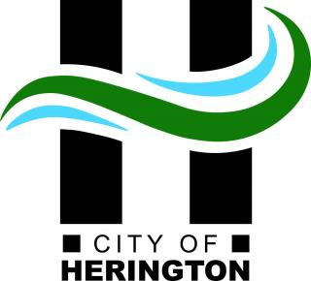

Ethics Complaint Form

As Approved in City Ordinance #1862
Please use this form to submit your request.
This form may be picked up at City Hall, mailed, or emailed by request. Please fill out and submit it to City Hall or call (785) 258 - 2271 for assistance.
Contact Person: Street Address & Apt. No.: City: State: Zip: Phone: Email: Complaint:

Please provide a complete description of the specific ethical concern relating to the section of the Code of Ethics Policy (Ord. 1862)

*Please attach any additional pages or supporting materials.
Signature: Date:

Return to: City of Herington, City Manager or City Clerk, 17 N Broadway, Herington, KS 67449

